THE PARISH CHURCH OF ST MICHAEL, ALNWICK

‘ALL ARE WELCOME IN THIS PLACE’
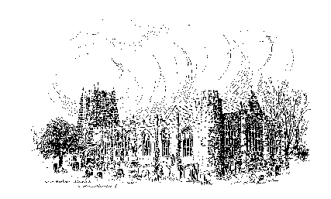

Sunday, 30th April 2023
FOURTH SUNDAY OF EASTER

A warm welcome to our worship today.
We hope you will stay for tea/coffee after the 10.00am service.

The wearing of a mask is a personal choice in St Michael’s

TODAY’S WORSHIP

8.30am Holy Communion
President & Preacher : Reverend Canon Sue Allen
10.00am Parish Communion
President & Preacher : Reverend Canon Sue Allen
6.00pm Said Evensong
Officiant : John Cooke

Acts 2 : 42 – 47
During the Easter season we are reading about the young church in action, in the power of the resurrection.
We have heard Peter’s first recorded sermon, and its dramatic effect. Now we discover how these new Christians came to develop a new pattern of life and worship together.

John 10 : 1 – 10
Jesus uses a familiar image from the Hebrew Scriptures of shepherds and sheep. He is himself the good shepherd; he calls us to follow him, and teaches that he is himself the only way the sheep may be safely gathered.

HYMNS 10.00am
366 Living God, your word has called us
800 The Lord’s my shepherd, I’ll not want
604 Brother, sister, let me serve you
493 Hope of our calling: hope through courage won

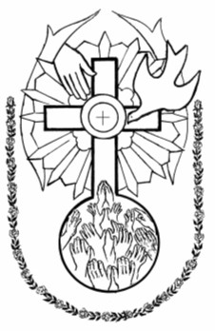
For your prayers this week …
Holy Spirit, who moves within and among us, around us and ahead, we thank You for the fellowship we have in You.
You are the bond between us, who breathes into the life of our community.
Inspire us, we humbly pray that in the life that we share together as a community of faith, as Church, people may know themselves loved as Jesus loves.

May we be communities of reconciliation, seeking restorative justice, building bridges, making connections, reaching out to others, to the glory of Your holy name.
Especially we pray for people in challenging places;
in countries recovering from earthquake, in places where there is war,
in situations where people have been hurt by the actions of others,
and where relationships are fractured.
God of peace, may the love with which the Good Shepherd tends all the flock, restore the image of God in us all.

On this the Sunday before the Coronation of King Charles III
we pray for His Majesty the King and for Camilla, the Queen Consort.
May Your Spirit be with them as they are affirmed in their responsibilities;
grant them joy and may we be encouraged by their interest and concern.
We pray for all whose office and responsibilities affect the lives of many,
for those who represent their country's interests, that in all they do they may be mindful of the wellbeing of every child of God.

Thank You, for the good work of grace that You have begun in our lives and all those with whom we are called to minister, especially Reverend Mitch, our Vicar designate. May we all be kept humble before You and prevent us from an attitude of self-inflated importance but rather let us keep our eyes fixed on Jesus, the author and finisher of our faith and ministry.

Jesus, Crucified, Risen and Ascended Lord,
You intercede for us before the throne of God, thanks be to You!
Holy Spirit You, help us to pray in sounds too deep for words, thanks be to You!
Creator of life, You call us to life anew; thanks be to You!
These prayers we offer to the one in whom we live and move and have our being, to whom be all glory and praise. Amen

THE WEEK AHEAD
Monday, 1st May
10.00am Full peal of bells by Exeter Cathedral Ringers
Wednesday, 3rd
10.15am Holy Communion
Thursday, 4th
9.30am Mini Michael’s
Saturday, 6th Coronation of His Majesty King Charles III
2.00pm Bell ringing celebration throughout the afternoon
Sunday, 7th FIFTH SUNDAY OF EASTER
8.30am Holy Communion
President & Preacher : Bishop Mark
10.00am Parish Communion
President & Preacher : Bishop Mark
2.00pm Baptism of Isaac Andrew Guthrie
6.00pm Deanery Evensong
With a United Choir, led by Janet Maloney (Director of Music at Warkworth)

LOOKING AHEAD
Tuesday, 9th
7.00pm PCC Meeting in Parish Hall
Wednesday, 10th
10.15am Holy Communion
2.00pm Mothers’ Union Meeting in Church
Thursday, 11th
9.30am Mini Michael’s
Saturday, 13th
4.00pm Installation of The Reverend Christian Mitchell as Vicar of the Parish of Alnwick.

HOLY LAND PILGRIMAGE - 2024

Led by Robert Chavner and Philip Bourne.

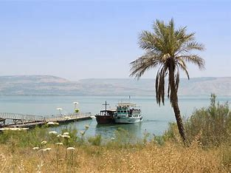
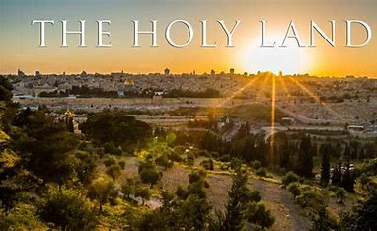
The pilgrimage, in the week 4 - 11 March 2024, will include the sites where the most important events in Our Lord’s life and ministry took place: in Jerusalem and the surrounding area and further north in Galilee. A visit to the Holy Land can be a life changing journey as well as a faith changing experience and lots of fun, too! Please do consider joining us for this trip of a lifetime. For details, brochure and booking form, please speak to Robert or Philip asap.

Christian Aid Week 14th – 20th May
Michelle’s and Andrew’s plant stall and refreshments will take place on the final Saturday of Christian Aid Week (20th May), 10.00am – 4.00pm (in the alleyway leading to their home, between Barclays and Lloyds Banks).
Please consider if you might be able to help for an hour or two on the stall, serving tea and cake or perhaps by making a tray bake or scones in advance, (no savoury items please).
Thank you. Sue, Michelle and Andrew

‘Chop the Mop’ update - £1126.25. Fr Robert thanks all who contributed to the amazing amount raised for Prostate Cancer UK in memory of the late Michele Roszak.
__________________________________________________________________________________________________________________________________

You can now give on-line to the church by scanning this QR code,
or you are welcome to use our new cashless machine at the back
of church. Thanks for your support.

__________________________________________________________________________________________________________________________________

01665 602797
Parish Website: www.alnwickanglican.com
If you are a UK taxpayer, St. Michael’s can benefit to the tune of 25p for each £1.00 donated by Gift Aid. Please use the envelopes available at the back of church.
Thank you.
The Parish of St. Michael & St. Paul is a Registered Charity, No. 1131297

