THE PARISH CHURCH OF ST MICHAEL, ALNWICK

‘ALL ARE WELCOME IN THIS PLACE’
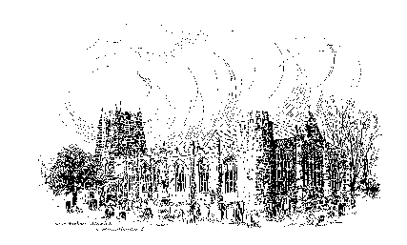

Sunday, 23rd April 2023
THIRD SUNDAY OF EASTER

A warm welcome to our worship today.
We hope you will stay for tea/coffee after the 10.00am service.

The wearing of a mask is a personal choice in St Michael’s

TODAY’S WORSHIP

8.30am Holy Communion
President & Preacher : Reverend Canon Dr Philip Bourne
10.00am Parish Communion
President & Preacher : Reverend Canon Dr Philip Bourne
6.00pm Compline
Officiant : Annette Playle

Acts 2 : 14a, 36 – 41
During this Easter season we hear of the power of the risen Christ in the early church.
This reading is the culmination of a sermon we began last Sunday. Peter has been speaking to the Jews at Pentecost, proclaiming the crucified Jesus as their Lord and Messiah. Those who now respond are baptised and join the believing community.

Luke 24 : 13 – 35
Luke’s Easter evening takes us on the road from Jerusalem to Emmaus, where the risen Jesus joins two of his friends as they walk and talk. Only when, at supper, he takes bread, gives thanks, breaks it and shares it, do they come to recognise him.
HYMNS 10.00am
216 The day of resurrection!
212 Now the green blade rises from the buried grain
198 At the Lamb’s high feast we sing (omit v3)
421 All for Jesus, all for Jesus

CLOSING VOLUNTARY

Church Sonata No 6 in C major by W T Best

HYMNS 6.00pm

358 Be still, for the presence of the Lord

794 The King of love my shepherd is

For your thoughts and prayers this week...

O God, your Son remained with his disciples after his resurrection,
teaching them to love all people as neighbours.
As his disciples in this age,
we offer our prayers on behalf of the world
in which we are privileged to live
and our neighbours with whom we share it.
Open our hearts to your power moving
around us and between us and within us,
until your glory is revealed in our love of both friend and enemy,
in communities transformed by justice and compassion,
and in the healing of all that is broken.
Guide us in the path of discipleship,
so that, as you have blessed us,
we may be a blessing for others,
bringing the promise of the kingdom near
by our words and deeds.
Hear our prayers, O God,
and transform us through them,
that we may have eyes to see and hearts to understand
not only what you do on our behalf,
but what you call us to do,
so that your realm will come to fruition in glory.
Elusive God,
companion on the way,
you walk behind, beside, beyond;
you catch us unawares.
Break through the disillusionment and despair
clouding our vision,
that, with wide-eyed wonder,
we may find our way
and journey on as messengers of your good news.
Amen.

THE WEEK AHEAD
Wednesday, 26th
10.15am Holy Communion
Thursday, 27th
9.30am Mini Michael’s
Sunday, 30th FOURTH SUNDAY OF EASTER
8.30am Holy Communion
President & Preacher : Reverend Canon Sue Allen
10.00am Parish Communion
President & Preacher : Reverend Canon Sue Allen
6.00pm Said Evensong
Officiant : John Cooke

LOOKING AHEAD
Monday, 1st May
10.00am Full peal of bells by Exeter Cathedral Ringers
Wednesday, 3rd
10.15am Holy Communion
Thursday, 4th
9.30am Mini Michael’s
Saturday, 6th Coronation of His Majesty King Charles III
2.00pm Bell ringing celebration throughout the afternoon
Sunday, 7th
8.30am Holy Communion
President & Preacher : Bishop Mark
10.00am Parish Communion
President & Preacher : Bishop Mark
6.00pm Deanery Evensong
Saturday, 13th
4.00pm Institution of The Reverend Christian Mitchell as Vicar of Alnwick.

HOLY LAND PILGRIMAGE - 2024

Led by Robert Chavner and Philip Bourne.

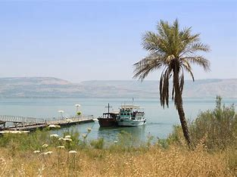
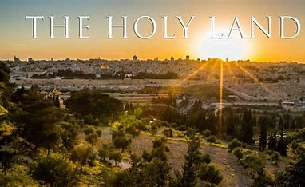
The pilgrimage, in the week 4 - 11 March 2024, will include the sites where the most important events in Our Lord’s life and ministry took place: in Jerusalem and the surrounding area and further north in Galilee. A visit to the Holy Land can be a life changing journey as well as a faith changing experience and lots of fun, too! Please do consider joining us for this trip of a lifetime. For details, brochure and booking form, please speak to Robert or Philip asap.

Christian Aid Week 14th – 20th May
Michelle’s and Andrew’s plant stall and refreshments will take place on the final Saturday of Christian Aid Week (20th May), 10.00am – 4.00pm (in the alleyway leading to their home, between Barclays and Lloyds Banks).
Please consider if you might be able to help for an hour or two on the stall, serving tea and cake or perhaps by making a tray bake or scones in advance, (no savoury items please).
Thank you. Sue, Michelle and Andrew

__________________________________________________________________________________________________________________________________

You can now give on-line to the church by scanning this QR code.
Or you are welcome to use our new cashless machine at the back
of church. Thanks for your support.

__________________________________________________________________________________________________________________________________

01665 602797
Parish Website: www.alnwickanglican.com
If you are a UK taxpayer, St. Michael’s can benefit to the tune of 25p for each £1.00 donated by Gift Aid. Please use the envelopes available at the back of church.
Thank you.
The Parish of St. Michael & St. Paul is a Registered Charity, No. 1131297

