THE PARISH CHURCH OF ST MICHAEL, ALNWICK

‘ALL ARE WELCOME IN THIS PLACE’
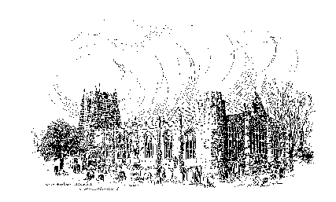

Sunday, 16th April 2023
SECOND SUNDAY OF EASTER

A warm welcome to our worship today.
We hope you will stay for tea/coffee after the 10.00am service.

The wearing of a mask is a personal choice in St Michael’s

TODAY’S WORSHIP

8.30am Holy Communion (BCP)
President & Preacher : Reverend Robert Chavner
10.00am Parish Communion
President & Preacher : Reverend Robert Chavner
6.00pm Said Evensong
Officiant : John Cooke

Acts 2 : 14a, 22 – 32
On the Day of Pentecost, a crowd gathered to listen to the Apostles speak of the risen Christ. Peter shows how a Psalm of David can now be seen as proof that everything that had happened was within God’s plan of salvation.
John 20 : 19 – 31
On the first Easter evening, Jesus appears to his disciples with his habitual greeting of peace, and a gift of the Holy Spirit. Thomas must wait another week until he can see, believe, and adore.
HYMNS 10.00am
194 Alleluia! Alleluia! Hearts to heaven and voices raise
199 Christ is alive! Let Christians sing
197 Alleluia, alleluia, give thanks to the risen Lord
218 Thine be the glory, risen, conquering Son
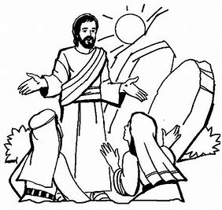

Prayers for this week …

Prayer of adoration …
Glorious God of all, You are the giver of new life,
You are the one to whom we owe each breath,
You are the reason for our hope.
Send Your enlivening spirit, be present with us as we come close to You,
seeking Your light to see what has been revealed
seeking Your warmth to set hearts aglow with Your love
seeking Your truth, that we might trust.
As we proclaim the Easter gospel, that in You is life which conquers death,
make us anew Your beloved children. Amen

Prayer of confession …
Merciful God, we confess that too often we have lived lives of those not worthy to be called Your children.
Though You are light, we have preferred to lurk in shadow,
though You are truth, we have made idols of lies and falsehood,
though You are love, we have been hard of heart.
Too often You show us the Way, and we have wandered far off course.
We turn to You now with repentant hearts, and seek Your forgiveness.
We lay claim to your promise, and pray that You will transform us, re-make us, that we will live as Your children, and by word, thought and deed, we might lead lives worthy of people within Your kingdom of love, peace and mercy. Amen

Prayer of thanksgiving …
God of bountiful blessing,
we thank You for the promise of Jesus Christ, who is the Life by which we live, and the perfection of Your holy glory.
We thank You for the faith to believe that which we have not seen,
and for Your mercy upon us as we clumsily grasp the significance of Your love.
We thank You for Your sustaining strength as we try to lead lives which reflect Your glory, and for Your ever-present Spirit as our guide, helper and advocate.
With thankful hearts we give You praise. Amen

THE WEEK AHEAD
Wednesday, 19th
10.15am Holy Communion
Thursday, 20th
9.30am Mini Michael’s
Sunday, 23rd April THIRD SUNDAY OF EASTER
8.30am Holy Communion
President & Preacher : Reverend Canon Dr Philip Bourne
10.00am Parish Communion
President & Preacher : Reverend Canon Dr Philip Bourne
6.00pm Compline
Officiant : Annette Playle

LOOKING AHEAD
Wednesday, 26th
10.15am Holy Communion
Thursday, 27th
9.30am Mini Michael’s

HOLY LAND PILGRIMAGE - 2024

Led by Robert Chavner and Philip Bourne.

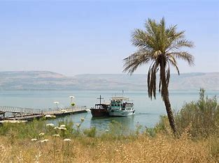
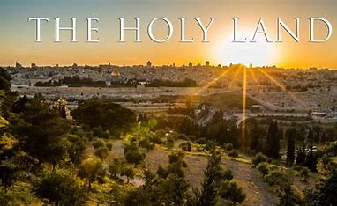
The pilgrimage, in the week 4 - 11 March 2024, will include the sites where the most important events in Our Lord’s life and ministry took place: in Jerusalem and the surrounding area and further north in Galilee. A visit to the Holy Land can be a life changing journey as well as a faith changing experience and lots of fun, too! Please do consider joining us for this trip of a lifetime. For details, brochure and booking form, please speak to Robert or Philip asap.

Greener Together While the household waste recovery site (on the Lionheart estate) does a good job of recycling a lot of unwanted items, it is even better if the things which we no longer need can be given a second chance in their original state. Please do consider using www.freecycleng.org. It is quite astonishing what people will take off your hands – spare pieces of laminate flooring, shelving, old computer (not working!), plants, top soil, old paving slabs, and even a collection of tins of paint with only a little left in the bottom. (Of course, one may also find something that is needed on the website, current offers include a wormery bin, a chest of drawers, printer cartridges.)
Just sign into the website and then choose ‘Alnwick’. (If you are offering an item, it is up to the recipient to collect it from you and vice versa.) Sue Wiltshire

As you know our new priest, the Reverend Christian Mitchell (Mitch) is being installed by the Bishop of Newcastle on Saturday, 13th May at 4.00pm. We have been invited to lead the singing in choir for this very special and important service. If you would like to form part of the choir for this service, please speak to the Reverend Robert Chavner.

__________________________________________________________________________________________________________________________________

You can now give on-line to the church by scanning this QR code.
Or you are welcome to use our new cashless machine at the back
of church. Thanks for your support.

__________________________________________________________________________________________________________________________________

01665 602797
Parish Website: www.alnwickanglican.com
If you are a UK taxpayer, St. Michael’s can benefit to the tune of 25p for each £1.00 donated by Gift Aid. Please use the envelopes available at the back of church.
Thank you.
The Parish of St. Michael & St. Paul is a Registered Charity, No. 1131297

