THE PARISH CHURCH OF ST MICHAEL, ALNWICK

‘ALL ARE WELCOME IN THIS PLACE’
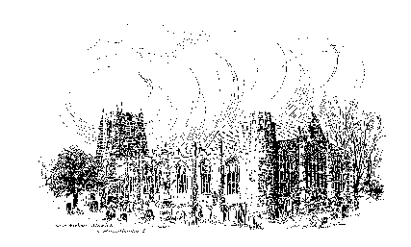

Sunday, 9th April 2023
EASTER DAY
ALLELUIA! CHRIST IS RISEN! HE IS RISEN INDEED! ALLELUIA!

A warm welcome to our worship today.
We hope you will stay for tea/coffee after the 10.00am service.

The wearing of a mask is a personal choice in St Michael’s

TODAY’S WORSHIP

8.30am Holy Communion (BCP)
President & Preacher : Reverend Canon Peter Askew
10.00am Parish Communion
President & Preacher : Reverend Canon Peter Askew
6.00pm Taizé Style Evening Prayers
Officiant : Annette Playle

Acts 10 : 34 – 43
This is a small part of the story of Peter and a centurion of the Roman occupying army, when the Gospel first reached beyond the Jews. The teaching sums up Jesus’s old and new life.
John 20 : 1 – 18
Mary Magdalene is sometimes called ‘The Apostle to the Apostles’, for she was the first to see the risen Lord and tell the others. But his appearance had changed, and only love speaking to love made him known to her.
HYMNS 10.00am
205 Jesus Christ is risen today, Alleluia
193 All heaven declares the glory of the risen Lord
200 Christ the Lord is risen again
207 Jesus lives!

CHANTS 6.00pm
Bless the Lord
Laudate Dominum
In the Lord

A Resurrection Prayer (by Kathy Galloway)
Christ our life,
you are alive - in the beauty of the earth,
in the rhythm of the seasons,
in the mystery of time and space. Alleluia.
Christ our life,
you are alive - in the tenderness of touch,
in the heartbeat of intimacy,
in the insights of solitude. Alleluia.
Christ our life,
you are alive - in the creative possibility
of the dullest conversation,
of the dreariest task,
of the most threatening event. Alleluia.
Christ our life,
you are alive - to offer re-creation
to every unhealed hurt,
to every deadened place,
to every damaged heart. Alleluia.
You set before us a great choice.
Therefore we choose life.
The dance of resurrection soars and
surges through the whole creation.
This is grace, dying we live.
So let us live. Amen.
Easter Prayer (by the Reverend Michaela Youngson)
When everything was dark
and it seemed that the sun would never shine again,
your love broke through.
Your love was too strong,
too wide,
too deep
for death to hold.
The sparks cast by your love
dance and spread
and burst forth
with resurrection light.
Gracious God,
we praise you for the light of new life
made possible through Jesus.
We praise you for the light of new life
that shone on the first witnesses of resurrection.
We praise you for the light of new life
that continues to shine in our hearts today.
We pray that the Easter light of life, hope and joy,
will live in us each day;
and that we will be bearers of that light
into the lives of others. Amen.

THE WEEK AHEAD
Tuesday, 11th
12noon Annual Meeting of the Ancient Four & Twenty
7.00pm PCC Meeting in Parish Hall
Wednesday, 12th
10.15am Holy Communion
2.00pm Mothers’ Union Meeting in church
Saturday, 15th
10,00am ‘Toilet Twinning’ Coffee Morning in St James’s Church
11.00am Messy Church

Sunday, 16th April SECOND SUNDAY OF EASTER
8.30am Holy Communion (BCP)
President & Preacher : Reverend Robert Chavner
10.00am Parish Communion
President & Preacher : Reverend Robert Chavner
6.00pm Said Evensong
Officiant : John Cooke
LOOKING AHEAD
Wednesday, 19th
10.15am Holy Communion
Thursday, 20th
9.30am Mini Michael’s

HOLY LAND PILGRIMAGE - 2024

Led by Robert Chavner and Philip Bourne.

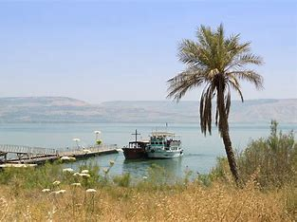
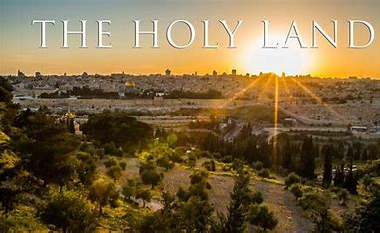
The pilgrimage, in the week 4 - 11 March 2024, will include the sites where the most important events in Our Lord’s life and ministry took place: in Jerusalem and the surrounding area and further north in Galilee. A visit to the Holy Land can be a life changing journey as well as a faith changing experience and lots of fun, too! Please do consider joining us for this trip of a lifetime. For details, brochure and booking form, please speak to Robert or Philip asap.

Lent Lunches Donations totalled £1,206. This will be split between Cafod, Christian Aid and Alnwick District Food Bank.

__________________________________________________________________________________________________________________________________

You can now give on-line to the church by scanning this QR code.
Or you are welcome to use our new cashless machine at the back
of church. Thanks for your support.

__________________________________________________________________________________________________________________________________

01665 602797
Parish Website: www.alnwickanglican.com
If you are a UK taxpayer, St. Michael’s can benefit to the tune of 25p for each £1.00 donated by Gift Aid. Please use the envelopes available at the back of church.
Thank you.
The Parish of St. Michael & St. Paul is a Registered Charity, No. 1131297

