THE PARISH CHURCH OF ST MICHAEL, ALNWICK

‘ALL ARE WELCOME IN THIS PLACE’
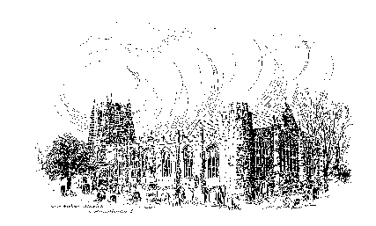

Sunday, 19th March 2023
THE FOURTH SUNDAY OF LENT
Mothering Sunday
A warm welcome to our worship today.
We hope you will stay for tea/coffee after the 10.00am service.

The wearing of a mask is a personal choice in St Michael’s

TODAY’S WORSHIP

8.30am Holy Communion (BCP)
President & Preacher : Reverend Canon Sue Allen
10.00am First Sunday Eucharist – ‘Say it with flowers’
President & Preacher : Reverend Canon Sue Allen

Exodus 2 : 1 – 10
The mother of Moses worked a deception to preserve her son’s life, when the Egyptians were controlling the population by killing every new-born Jewish boy.

Luke 2 : 33 – 35
Jesus is the son of a human mother, just like us. In the Gospel, his earthly father and mother fade into the shadows as the nature of his life is hinted at. Yet we never forget his home, the love and teaching he received.

HYMNS 10.00am
All our blessings all our joys (see overleaf)
725 Make me a channel of your peace
437 ‘Come to me’, says Jesus
136 Fathers and mothers

All our blessings

All our blessings, all our joys
With thankful hearts we sing,
Lord of life and Lord All love,
Accept the praise we bring.

1 For parents and for children, 3 For all who’ve shared our sorrow,
For husbands, wives, and friends, Walked with us in our pain,
For those whose care enfolds us Who’ve held our hand through darkness
With love that never ends And showed us light again.
2 For fellowship and friendship 4 In sacrifice and service
We both receive and give, Your love is clearly shown,
For those who’ve shared our journey Your outstretched arms embrace us
And taught us how to live. To bring us safely home

© Ally Barrett Used with permission

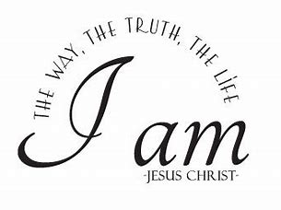
For your prayers, this week …
A Prayer of Thanksgiving …

We are grateful God, for Your leading and guiding.
You are willing to get Your hands dirty for us
to give us a glimpse of Your vision of the world.
You do not hide who You are
but You let us ask questions and come to the wrong conclusions!

You don't leave us where we are, but You invite us to
speak out truth
strive for peace
fight for justice
work for healing
make disciples.

Thank You for trusting us to be Your co-workers in realising the dream of God. Amen.

A Prayer for Others

Shepherding God, help us to be more aware of Your presence with us.
As we move through life, may we live and move in You.
Help us at each stage of our journey to recognise Your rod and staff comforting us.
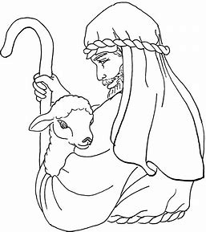
We pray for all who seek green pastures
We pray for all who seek still waters
We pray for all who seek restoring of their soul
We pray for all who seek right paths before them
We pray for all who find themselves in dark valleys
We pray for all who sit with their enemies around them

We pray that Your goodness and mercy will go before us,
will follow us, will uphold us and comfort us, all the days of our lives. Amen

A Prayer of discipleship …
God of goodness send us out to tell truth, to do good, and to work for righteousness.
Empower us to live as children of light in Your world. Amen

THE WEEK AHEAD
Tuesday 21st
7.00pm St Michael’s Bowls Club in the Parish Hall
Wednesday, 22nd
10.15am Holy Communion
Thursday, 23rd
9.30am Mini Michael’s
12 noon Lent Lunch in St James’s Church Hall
Saturday 25th
10.00am BIG CLEAN (see over)
Sunday, 26th THE FIFTH SUNDAY OF LENT
8.30am Holy Communion
President & Preacher : Reverend Alison Hardy, Area Dean
10.00am Parish Communion
President & Preacher : Reverend Alison Hardy, Area Dean

Followed by ANNUAL PAROCHIAL CHURCH MEETING
LOOKING AHEAD
Monday 27th
10.00am Funeral of Sheila Vint
Tuesday 28th
7.00pm St Michael’s Bowls Club in the Parish Hall
Wednesday, 29th
10.15am Holy Communion
2.00pm School Easter Service Rehearsal
Thursday, 30th
9.30am Mini Michael’s
12 noon Lent Lunch in St James’s Church Hall
2.00pm School Easter Service

Copies of the Annual Report for the Annual Parochial Church Meeting are at the back of church. Please take one before you leave church today so that you can read it before the meeting.
For those who collected their APCM packs last week, please note that there is a supplementary sheet with two late items available at the back of church.

We are having a Big Clean in church on Saturday, 25th March from 10.00am. Please try to come along even if you can only spare an hour. All cleaning materials will be provided and also refreshments. Please help us make St Michael's sparkling clean for the Easter Celebrations!

The Food Bank have put out an appeal for Easter eggs which will be given to families over the holiday. If you feel able to provide a chocolate egg for this appeal, please bring them into church by March 26th.

Aid for Ukraine There is a collection point at The Willowburn Sports Centre for items which will be taken soon, by lorry, to Ukraine. Goods can be left until and including Wednesday 22nd March.
New items : first aid kits and dressings, personal hygiene items, sanitary protection, mini toiletries, dried foods, high energy bars drinks and snacks.
Electrical items - lanterns, torches, power packs and batteries.
Underwear and socks.

Churchwardens
Pat Taylor Anne Blades
: 01665 603811 : 01665 602020

Parish Website: www.alnwickanglican.com
If you are a UK taxpayer, St. Michael’s can benefit to the tune of 25p for each £1.00 donated by Gift Aid. Please use the envelopes available at the back of church.
Thank you.
The Parish of St. Michael & St. Paul is a Registered Charity, No. 1131297

