THE PARISH CHURCH OF ST MICHAEL, ALNWICK

‘ALL ARE WELCOME IN THIS PLACE’
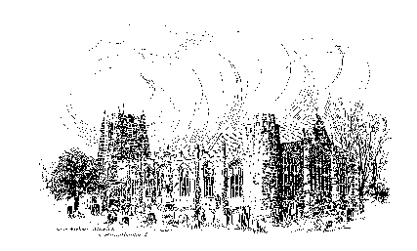

Sunday, 5th March 2023
THE SECOND SUNDAY OF LENT
A warm welcome to our worship today.
We hope you will stay for tea/coffee after the 10.00am service.

The wearing of a mask is a personal choice in St Michael’s

TODAY’S WORSHIP

10.00am First Sunday Eucharist - ‘Night Visitor’
President & Preacher : Reverend Canon Sue Allen
6.00pm Deanery Evensong

Genesis 12 : 1 – 4a
Last Sunday we heard the sad tale of mankind’s first disobedience. This reading is a happier circumstance, with consequences just as far-reaching. God’s demand to Abraham is to start anew – to be ‘new-born’ as Jesus later told Nicodemus. Because Abraham is totally obedient, God’s purpose can begin in his chosen people.
John 3 : 1 – 17
Jesus seems to demand the impossible – that we be born again. But he means that faith in his redeeming love brings us spiritual re-birth, into a wholly new kind of living.

HYMNS 10.00am
592 As the deer pants for the water
494 I, the Lord of sea and sky
This is your body (see over)*
639 Give thanks with a grateful heart (During the administration of Communion)
652 Guide me, O thou great Redeemer

* This is your body, for your people giv’n,
We break the bread, and voice the sacred song;
Food of the angels, taste of highest heav’n,
crumbs dropped for all who fear we don’t belong:
We are your body, help us dare to share
all that we have, and offer all we are.
This is your blood, the pain that makes us whole
With love was pressed from Christ’s live-giving vine,
The smallest sip can warm the coldest soul,
And fill the human heart with fire divine:
We are your body, help us yearn to share
all that we have, and offer all we are.
We are your body, fed with heavenly food,
Washed through the blood that flows with heavenly love,
And then you send us, by that love renewed,
to find that earth is full of heav’n above.
We are your body, in your grace we share
all that we have, and offer all we are.

HYMNS at 6.00pm
827 Ye servants of God, your Master proclaim
787 Take my life, and let it be consecrated, Lord, to thee
135 Take up thy cross, the Saviour said

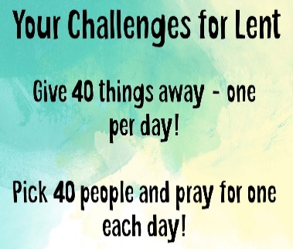
For your prayers this week …
God of all, you have called us to follow You.
You have called us to care for Your world and for Your children,
You have called us to be a blessing, not a curse.
When we look at our homes, our communities, and at the world around us,
we see signs of blessing, we also see the need for love and care.
As we think of all the different families that make up this community of faith, let us remember those who are away from us, and those who need to know You are close at this time.
Lord in Your mercy
Hear our prayers
We think of our community and all the different activities that take place in and around it, all the people who have grown up here, or moved here in recent times. We remember all those who live, work and minister here, who learn and play here, who love and care here, we bring them all before You now.
Lord in Your mercy
Hear our prayers
We think of our country and all of the different decisions being made in parliaments and councils. We think of communities facing many different challenges. God, we pray for healing, for fulness of life and for Your way of love to be the guiding rule.
Lord in Your mercy
Hear our prayers
As we think of the world that You so loved so much that You gave Your only Son, as we continue to come and go, we pray for Your guidance – help us to be aware of the impact we are having on the planet and on others.
Lord in Your mercy
Hear our prayers
Merciful God, help us to care for and to love all of Your children. Inspire us to speak out truth to power and healing to division and may we be a blessing to all whom we encounter and humbly receive the blessing from those who encounter us. Amen
THE WEEK AHEAD
Tuesday 7th
7.00pm St Michael’s Bowls Club in the Parish Hall
7.00pm PCC Meeting – Parish Hall
Wednesday, 8th
10.15am Holy Communion
2.00pm Mothers’ Union Meeting in church
Thursday, 9th
9.30am Mini Michael’s
12 noon Lent Lunch in St James’s Church Hall
Friday, 10th
10.30am Funeral of John William Hopper
Sunday, 12th THE THIRD SUNDAY OF LENT
10.00am Parish Communion
President & Preacher : Reverend Canon Dr Philip Bourne
6.00pm Said Evensong Officiant : John Cooke
LOOKING AHEAD
Tuesday 14th
7.00pm St Michael’s Bowls Club in the Parish Hall
Wednesday, 15th
10.15am Holy Communion
1.30pm Funeral of Alice Mason
Thursday, 16th
9.30am Mini Michael’s
12 noon Lent Lunch in St James’s Church Hall
Friday, 17th
10.00am Funeral of Rose Stewart
Saturday, 18th
11.00am Messy Church
Sunday, 19th Mothering Sunday will be First Sunday Eucharist

Our Annual Parochial Church Meeting will be held on Sunday, March 26th immediately after the 10am Parish Eucharist. New members are needed for the PCC. If you feel this is something you would like to be part of, there are forms at the back of church. Please take one. Any present member of the PCC will be happy to help if you have any questions.

Christian Aid Week 14th - 20th May 2023
For the last two years a very successful plant stall has been held during this important week and the response to the request to grow whatever you feel able has been marvellous. So, once again, even if all you have is a warm windowsill, please can you plant a few seeds or grow a few cuttings to help towards this year’s effort. The money raised during Christian Aid week is needed more than ever. Thank you, Sue Wiltshire

Churchwardens
Pat Taylor Anne Blades
: 01665 603811 : 01665 602020

Parish Website: www.alnwickanglican.com
If you are a UK taxpayer, St. Michael’s can benefit to the tune of 25p for each £1.00 donated by Gift Aid. Please use the envelopes available at the back of church.
Thank you.
The Parish of St. Michael & St. Paul is a Registered Charity, No. 1131297

