THE PARISH CHURCH OF ST MICHAEL, ALNWICK

‘ALL ARE WELCOME IN THIS PLACE’
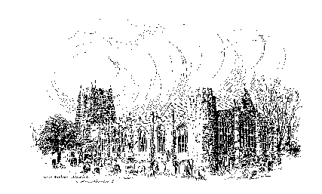

Sunday, 2nd April 2023
PALM SUNDAY

A warm welcome to our worship today.
We hope you will stay for tea/coffee after the 10.00am service.

The wearing of a mask is a personal choice in St Michael’s

TODAY’S WORSHIP

8.30am Holy Communion (BCP)
President & Preacher : Reverend Canon Peter Askew
10.00am Parish Communion
President & Preacher : Reverend Canon Peter Askew
6.00pm Deanery Evensong
Officiant : Reverend Robert Chavner
Preacher : Reverend Canon Dr Philip Bourne

Philippians 2 : 5 – 11
It is our faith that ‘Jesus Christ is Lord’, because he came from God in total self-giving, and overcame the humiliation of death on a cross by rising and ascending, He is indeed worthy of our adoration and worship

HYMNS 10.00am
160 Make way, make way
161 Ride on, ride on in majesty!
142 Glory be to Jesus
147 My song is love unknown (omit vv 4,6)

HYMNS 6.00pm
580 Judge eternal, throned in splendour
621 Dear Lord and Father of mankind
156 We sing the praise of him who died
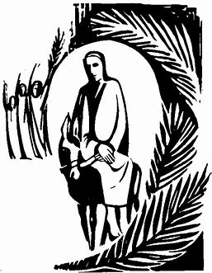
For your prayers this HOLY WEEK …
Living God, in the image of Christ's entry into Jerusalem when the Passover was coming, we see all the people around Him, just as we have countless numbers who crowd into our thoughts as we turn to You in prayer.
So, as Christ placed Himself in the midst of the crowd, let us be aware of the centrality of that same Christ to the people for whom we pray, that they, and we, might know they are close to our Lord and that He is always with them.
We pray, with the excitement of the children, for all who celebrate today: the newness of a birth; the fresh start of a marriage; good news about their health; the success of a task; a new way love has been expressed and felt. Let our voices join with theirs, as we shout, "Hosanna! Christ is here!"
We pray, with loyal disciples, for those who show their commitment, who prepare for Jesus' presence, who give their cloaks for His service, who make the way clear so that others can follow the procession. Let our voices join with theirs, as we shout, "Blessed is he who comes in the name of the Lord."
We pray, with the people in the crowd, for those who watch and wait: for the ‘not so sure' people; for the silent majority; for those who have little to celebrate; for the many who don't see the point. Let our voices not drown out their silent prayers, but in being aware of their needs, let our prayers carry their yearnings to our Lord.
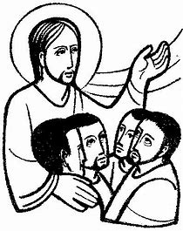
We pray, with those who know nothing of this, who live with anger and not expectation, with pain and not Hosannas, with scepticism and not acceptance. Let our voices not condemn them, but pray for them and with them. For the unknown, yet needful people we pray, as we look beyond the crowd and see …
Silence
Let us be aware on this day of rejoicing that many cannot or will not rejoice. Let us also be aware too, that Christ comes into the midst of all of this, to understand, to be fully present, to die and to rise, for each and every one of us. Amen.
THE WEEK AHEAD
Wednesday, 5th
10.15am Holy Communion
Thursday, 6th Maundy Thursday
7.30pm Eucharist with sermon and foot washing
Reverend Canon Sue Allen
Friday, 7th Good Friday
2.00pm An hour before the cross Reverend Colin Perkins
Sunday, 9th April EASTER DAY
8.30am Holy Communion
President & Preacher : Reverend Canon Peter Askew
10.00am Parish Communion
President & Preacher : Reverend Canon Peter Askew
6.00pm Taizé Style Evening Prayers
Officiant : Annette Playle

LOOKING AHEAD
Tuesday, 11th
12noon Annual Meeting of the Ancient Four & Twenty
Wednesday, 12th
10.15am Holy Communion
2.00pm Mothers’ Union Meeting in church
Saturday, 15th
11.00am Messy Church

Fr Robert writes ... THANK YOU to everybody who contributed to my ‘Chop the Mop’ appeal for Prostate Cancer UK in memory of the late Michele Roszak. To date, an amazing £752.50 (including Gift Aid) has been raised.

HOLY LAND PILGRIMAGE - 2024

Led by Robert Chavner and Philip Bourne.

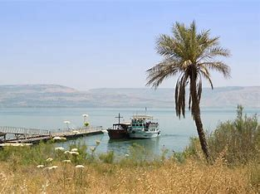
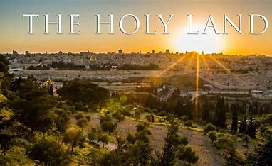
The pilgrimage, in the week 4 - 11 March 2024, will include the sites where the most important events in Our Lord’s life and ministry took place: in Jerusalem and the surrounding area and further north in Galilee. A visit to the Holy Land can be a life changing journey as well as a faith changing experience and lots of fun, too! Please do consider joining us for this trip of a lifetime. For details, brochure and booking form, please speak to Robert or Philip asap.

Easter Eggs
Please look out for the Fairtrade logo when buying your Easter eggs. (Aldi and Lidl have both have a very good selection!)

01665 602797
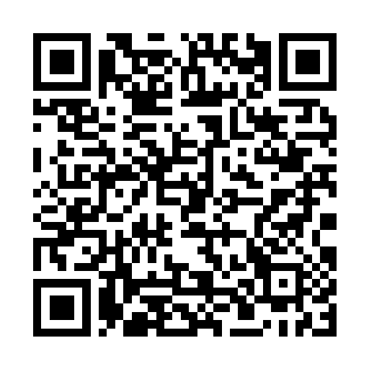
__________________________________________________________________________________________________________________________________

You can now give on-line to the church by scanning this QR code.
Or you are welcome to use our new cashless machine at the back
of church. Thanks for your support.

Parish Website: www.alnwickanglican.com
If you are a UK taxpayer, St. Michael’s can benefit to the tune of 25p for each £1.00 donated by Gift Aid. Please use the envelopes available at the back of church.
Thank you.
The Parish of St. Michael & St. Paul is a Registered Charity, No. 1131297

