THE PARISH CHURCH OF ST MICHAEL, ALNWICK

‘ALL ARE WELCOME IN THIS PLACE’
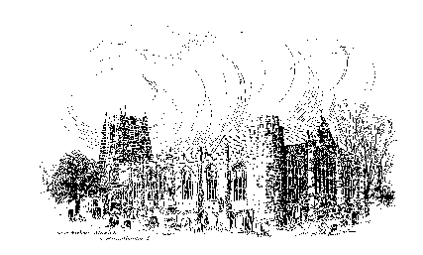

Sunday, 19th February 2023
THE SUNDAY NEXT BEFORE LENT
A warm welcome to our worship today.
We hope you will stay for tea/coffee after the 10.00am service.

The wearing of a mask is a personal choice in St Michael’s

TODAY’S WORSHIP

8.30am Holy Communion (BCP)
President & Preacher : Reverend Canon Peter Askew
10.00am Parish Communion
President & Preacher : Reverend Canon Peter Askew

2 Peter 1 : 16 – 21
This letter, in the name of Peter, reminds Christians of the second century that Jesus was no ordinary man, but one whom his first disciples had seen transfigured in glory, as God disclosed him to be his Son. All the prophecies had therefore come true.
Matthew 17 : 1 – 9
The Lord’s closest friends see him transfigured upon a mountain-top, in a disclosure of his true identity. In the presence of the figures of Moses and Elijah, a cloud of glory comes upon him and the voice of the holy one is heard.

HYMNS 10.00am
2 Christ, whose glory fills the skies
279 Jesus, on the mountain peak
281 ‘Tis good, Lord, to be here
719 Lord, the light of your love is shining

For your prayers this week...
…for Turkey and Syria
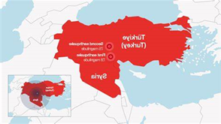
Please pray for the people of Central Turkey and North West Syria, whose lives have been devastated by the earthquake. Be present, O Lord, our Good Shepherd to bring comfort, relief, shelter and human kindness. Shield the people who suffer, console those who are bereaved, prosper the provision of relief, strengthen the work of emergency teams and shine your light and hope in the midst of despair. We pray this in the name of Jesus Christ our Lord. AMEN
…for Ukraine
God of strength and peace, send your blessing on the people of Ukraine. Sustain them in their struggles, hold them in their fear, protect them from all danger and be for them the hope they desire; for Jesus Christ’s sake. AMEN
As Myanmar, Afghanistan, Iran and other nations seethe with unrest and persecution, we pray for liberation and for new beginnings. Strengthen all who risk so much to stand for something better, kinder, fairer. Guide the leaders of the nations and bless the work of the United Nations and all who devote themselves to building international community and collaboration in the face of dictatorship, arrogance and suspicion.

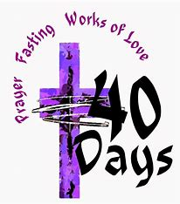
We give thanks to God for the appointment of Mitch as Parish Priest of Alnwick. We pray for him and his family as they prepare to move to Northumberland and he begins his ministry amongst our people. Let us pray for a faithful keeping of Lent and for an openness and willingness to work together for the building of God’s Kingdom in this place.

As communities stagger under threats from rising prices, services at breaking point, work that is undervalued and streets that are unsafe, let us pray for all who care for neighbours and seek a better day. For people forced to strike and for people whose lives become even harder on strike days. For negotiators and politicians, for those with power in their conversations and those who feel utterly powerless.

Loving God, in the midst of the world’s need and our hopefulness, hear the prayers we share. All these thoughts, all these words, all the prayers we cannot put into words, we offer in the name of Jesus Christ and in the power of the Holy Spirit. AMEN

THE WEEK AHEAD
Wednesday, 22nd Ash Wednesday
10.15am Holy Communion
Thursday, 23rd
12 noon Lent Lunch in St James’s Church Hall
Sunday, 26th THE FIRST SUNDAY OF LENT
8.30am Holy Communion
President : Reverend Robert Chavner Preacher : Annette Playle
10.00am Parish Communion
President : Reverend Robert Chavner Preacher : Annette Playle

LOOKING AHEAD
Tuesday 28th
7.00pm St Michael’s Bowls Club in the Parish Hall
Wednesday, 1st March
10.15am Holy Communion
Thursday, 2nd
9.30am Mini Michael’s

2023! Another chance to make a difference
As we move into the spring, our thoughts turn to new life and growth. Whether you have a large or small garden or no garden at all but only a few planters or a warm window sill, it is important to keep on being as ‘green’ as possible. Do you have any tried and tested tips you would like to share? Perhaps you make plant pots from old newspaper or bird feeders from plastic bottles. Whatever you do that works and avoids putting strain on our planet, we would love to hear about it.
Please send your thoughts to either Annette Playle at rene.p@btinternet.com or Sue Wiltshire at sue.wiltshire15@gmail.com. Ideas will be printed each week in the pew sheet and subsequently in ‘The Gateway.’ Thank you very much.
A message from :
‘The Alnwick Homes for Ukraine Community Support Group’
Please note: the message below is being circulated in the hope that it will, at some point, come to the notice of someone who can help. Hosting people in your home is not for everyone but if enough people can share the information below, hopefully there will be a good outcome. Thank you
There are two urgent requests locally:
1. Somewhere for a mother and two small children to stay in the area. If we cannot find somewhere by the end of February, they may have to return to Ukraine.
2. Somewhere for a young man (28), the brother of someone who is already here, who is allowed to come to the UK because of family trauma.

Our Annual Parochial Church Meeting will be held on Sunday March 26th immediately after the 10am Parish Eucharist. New members are needed for the PCC. If you feel this is something you would like to be part of, there are forms at the back of church. Please take one. Any present member of the PCC will be happy to help if you have any questions.

March 9th is the date that St. Michaels are hosting the Lent Lunch in St James's Church Hall. If you are able to make soup, help on the day or contribute to the cost of ingredients please speak to Anne or Pat.

Churchwardens
Pat Taylor Anne Blades
: 01665 603811 : 01665 602020

Parish Website: www.alnwickanglican.com
If you are a UK taxpayer, St. Michael’s can benefit to the tune of 25p for each £1.00 donated by Gift Aid. Please use the envelopes available at the back of church.
Thank you.
The Parish of St. Michael & St. Paul is a Registered Charity, No. 1131297

