THE PARISH CHURCH OF ST MICHAEL, ALNWICK

‘ALL ARE WELCOME IN THIS PLACE’
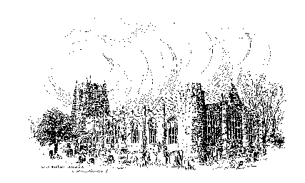

Sunday, 5th February 2023
THE THIRD SUNDAY BEFORE LENT
A warm welcome to our worship today.
We hope you will stay for tea/coffee after the 10.00am service.

The wearing of a mask is a personal choice in St Michael’s

TODAY’S WORSHIP

10.00am First Sunday Eucharist
President & Preacher : Reverend Canon Sue Allen
6.00pm Deanery Evensong

Luke 2 : 22 – 40 (dramatised)
As the Law requires, Jesus the first-born is brought to the Temple with a thanks-offering. Two old and holy people, Simeon and Anna, perceive that this child is the fulfilment of ancient prophecies of redemption, but the glory will not be without pain and suffering.

HYMNS 10.00am
112 New light has dawned, the Son of God is here
661 (verse 4 only) Glory, glory, glory to the Lord
74 Like a candle flame
Candlemas Hymn (on sheet)
719 Lord, the light of your love is shining

HYMNS 6.00pm
324 Jesus calls us: o’er the tumult
Anthem - There's a wideness in God's mercy (words: Frederick Faber; music: Maurice Bevan)
604 Brother, sister, let me serve you
'Thank you' to all our singers, choir director Janet Moloney and organist Roger Harrison.

For your prayers this week …
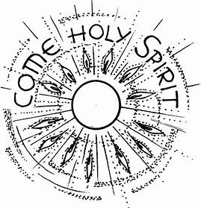
Lord, we pray for a fresh outpouring of your Holy Spirit upon your Church. We pray for our Bishops, Clergy and Laity meeting at General Synod this week. Teach us to walk in the right way, working together so that your will may be done. Enable us to honour the past but with eyes that are open to see the glorious presence of Christ and what He is doing now. May we look for God’s creative and transforming action around us and within us.

Lord, lead this planet in the paths that take us to a peaceful solution of all conflicts, particularly those that are entrenched and seem almost incapable of resolution. Inspire the hearts of all concerned that they may turn to you and receive your wisdom and light. Trusting in your word and in your love, may they begin the long and difficult ascent back to a just and peaceful world.
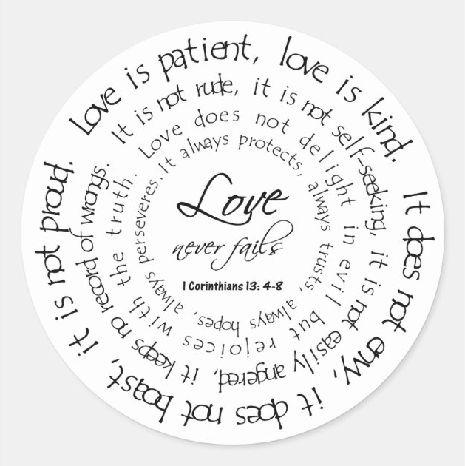
Lord, help us not to despise or oppose what we do not understand. Guard us from the danger of anger against our neighbours by reminding us at all times that, if they have offended us, we are also likely to have offended them. Give us the grace and courage to make our peace with those we live amongst, forgiving as we in turn pray to be forgiven.

Most loving Lord, as we turn our faces towards your Passion we pray for all who lie in the shadow of the cross. Give faith to the searching. Give healing to every broken life. Give release to those consumed by bitterness. Give light to those who sit in darkness. Give peace to the tormented. Give relief to those in pain or despair. Give hope to the dying.
Lord Christ, may we follow Your lig ht into all the darkness of the world,
overthrowing the old and tired ways,
fighting for justice,
forging paths to peace,
loving those it's hard to love,
knowing You go before us and call us to follow. AMEN.

THE WEEK AHEAD
Monday, 6th
7.00pm Mighty Oaks Prayer Evening – St James’s Church (see over)
Tuesday, 7th
7.00pm St Michael’s Bowls Club in the Parish Hall
Wednesday, 8th
10.15am Holy Communion
Thursday, 9th
9.30am Mini Michael’s
7.00pm ‘The Bamburgh Ossuary’ – A talk by Jessica Turner (see below)
Friday, 10th
10.00am Funeral of Grenville Ramsay
Sunday, 12th THE SECOND SUNDAY BEFORE LENT
10.00am Parish Communion
President & Preacher : Reverend Canon Dr Philip Bourne
6.00pm Said Evensong
Officiant : Annette Playle
LOOKING AHEAD
Tuesday, 14th
7.00pm St Michael’s Bowls Club in the Parish Hall
Wednesday, 15th
10.15am Holy Communion
Thursday, 16th
9.30am Mini Michael’s
Saturday, 18th
11.00am Messy Church

The Bamburgh Ossuary – A Talk by Jessica Turner
Everyone is invited to come along and hear Jessica speak. Her subjects will include Anglo-Saxons, early Christian Burial Practices, Northern Saints and more! Her tales are not to be missed! Although this talk will take place at the A.G.M of Christians Together in Alnwick (CtiA), anyone and everyone is invited. Refreshments will be served from 7.00pm, the meeting will begin at 7.15pm and it is hoped that Jessica will begin at 7.45pm. You are very welcome to enjoy your refreshments during the meeting or come along a little later.
St James‘s Church, Pottergate, Alnwick
Thursday 9th February
(Admission Free)

"Mighty Oaks" is a mobile hot drinks service run by Christians in Alnwick as a practical outreach to Alnwick’s late-night community on Saturday evenings. This has been operating since 2011 until Covid struck - but the plan is to re-launch after Easter. To prepare for this we will be having a 'Praying and Listening to God' evening for Mighty Oaks, Monday 6th February from 7-8pm, St James Church, Pottergate, Alnwick. We would welcome support for this - you don't have to be a Mighty Oaks volunteer, just willing to be part of our prayer support. For anyone interested in being involved as a volunteer, there will also be a 'barista' coffee training session after church on Sunday 5th March. For more details ask Andrew Duff (tel 07947 600779).

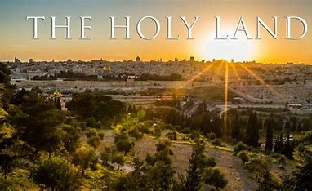
THE HOLY LAND - Lent 2024
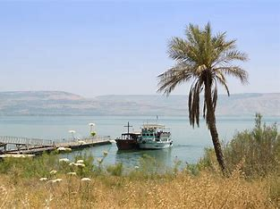
Following our successful holiday/pilgrimage to Austria and the Oberammergau Passion Play, for those of you who may be interested, Philip and I are leading a pilgrimage to the Holy Land, 4 – 11 March 2024, based in Jerusalem and Galilee. We would love you to join us. To register your interest, please let us know soonest and we can make sure you are included in the booking information mailing. Thank you. Fr Robert

Churchwardens
Pat Taylor Anne Blades
: 01665 603811 : 01665 602020

Parish Website: www.alnwickanglican.com
If you are a UK taxpayer, St. Michael’s can benefit to the tune of 25p for each £1.00 donated by Gift Aid. Please use the envelopes available at the back of church.
Thank you.
The Parish of St. Michael & St. Paul is a Registered Charity, No. 1131297

