THE PARISH CHURCH OF ST MICHAEL, ALNWICK

‘ALL ARE WELCOME IN THIS PLACE’
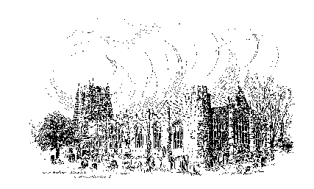

Sunday, 22nd January 2023
THE THIRD SUNDAY AFTER EPIPHANY
A warm welcome to our worship today.
We hope you will stay for tea/coffee after the 10.00am service.

The wearing of a mask is a personal choice in St Michael’s

TODAY’S WORSHIP

8.30am Holy Communion
President : The Reverend Martin Roff
Preacher : John Cooke
10.00am Parish Communion
President & Preacher : Bishop Mark

6.00pm Songs of Praise at St James’s Church, Shilbottle

1 Corinthians 1 : 10 - 18
We continue from last week the opening section of this letter. Paul has expressed his joy in their faith and confidence in their spiritual strength, yet quickly moves to deal with their internal disputes. They are to stop creating factions under different leaders; there is only one Gospel of Christ.

Matthew 4 : 12 - 23
Jesus’s public ministry began in and around Capernaum, on the shore of Lake Galilee. According to Matthew, this made true the prophecy of Isaiah, Jesus calls men from their daily work to share his mission work.
HYMNS 10.00am
52 The people that in darkness sat
569 The kingdom of God is justice and joy
99 Hail to the Lord’s Anointed
742 O for a thousand tongues to sing

For your prayers this week …
This is the season, Ancient of Days, in which time can seem to drag on. The holidays are complete, spring is still far off. After an autumn and early winter of preparations and holidays and new beginnings, we are now in that lax time. Protect us, O God, for those of us in winter’s throes, in still dark evenings and mornings missing daylight. Keep our hearts and minds healthy, O God, and help us to seek help when despair overtakes us. May the spirit of Advent, of active watching and waiting, be with us in this season after Epiphany, and in all times when we are waiting for something to come. May we be actively seeking to reveal You to the world, and take notice when You are revealed to us. In You we have all our hope, and we pray in Your name. Amen.

Creator God, you called Abram to be the father of many nations, and so we pray for the nations of our world and their leaders. We continue to pray for peace, and especially for those involved in the process of reconciliation and bridge-building between peoples, cultures or nations. Help us wherever and whenever we can in our everyday lives to be instruments of your peace.

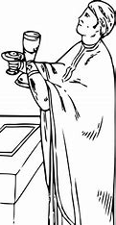
Heavenly Father as we come to the end of the Week of Prayer for Christian unity help us to listen to your voice calling us still to unity in our diversity. We pray for church leaders everywhere that they may work together and promote unity among Christians.

We especially pray for Helen-Ann, Bishop designate of Newcastle, Mark, Bishop of Berwick, our Vicar designate, Christian Mitchell and our ministry team here at St Michael’s. Bless them in their preparations and all their endeavours to further the Gospel of Jesus Christ here among us.

Faithful God, we rejoice in the call to belong to the Church, to believe in the Gospel, and to be united with the successors of your Apostles. May we never “labour in vain” and so send us out into the coming week ready to demonstrate our calling in all that we do and say.

THE WEEK AHEAD
Monday, 23rd
6.00pm Week of Prayer for Christian Unity – Baptist Church
Tuesday, 24th
10.30am Funeral of Raymond Topping
6.00pm Week of Prayer for Christian Unity – Society of Friends (in St James’s Church, Alnwick)
7.00pm St Michael’s Bowls Club in the Parish Hall
Wednesday, 25th
10.15am Holy Communion
6.00pm Week of Prayer for Christian Unity – St Michael’s
Thursday, 26th
9.30am Mini Michael’s
12.30pm Funeral of William Fletcher
Friday, 27th
11.30am Funeral of Ernest Lowdon
6.00pm Wedding rehearsal in church
Saturday 28th
12.30pm Wedding of Richard Brownlee and Jessica Robinson
*(See over)
Sunday, 29th THE FOURTH SUNDAY AFTER EPIPHANY
8.30am Holy Communion
President : The Reverend Canon Philip Bourne
Preacher : The Reverend Robert Chavner TSSF
10.00am Parish Communion
President : The Reverend Robert Chavner TSSF
Preacher : The Reverend Canon Philip Bourne

LOOKING AHEAD
Tuesday, 31st
7.00pm St Michael’s Bowls Club in the Parish Hall
Wednesday, 1st February
10.15am Holy Communion
Thursday, 2nd
9.30am Mini Michael’s

*Invitation to Wedding Service 28th January 12.30pm
Richard and Jess have felt very welcome at St Michael's, and would be very happy for you to attend their wedding service here, especially if you are a good singer!

"Mighty Oaks" is a mobile hot drinks service run by Christians in Alnwick as a practical outreach to Alnwick’s late-night community on Saturday evenings. This has been operating since 2011 until Covid struck - but the plan is to re-launch after Easter. To prepare for this we will be having a 'Praying and Listening to God' evening for Mighty Oaks, Monday 6th February from 7-8pm, St James Church, Pottergate, Alnwick. We would welcome support for this - you don't have to be a Mighty Oaks volunteer, just willing to be part of our prayer support. For anyone interested in being involved as a volunteer, there will also be a 'barista' coffee training session after church on Sunday 5th March. For more details ask Andrew Duff (tel 07947 600779).

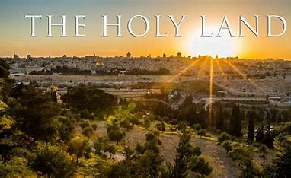
THE HOLY LAND - Lent 2024
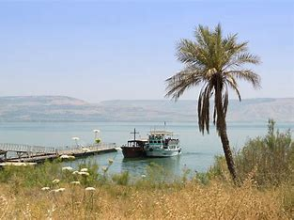
Following our successful holiday/pilgrimage to Austria and the Oberammergau Passion Play, for those of you who may be interested, Philip and I are leading a pilgrimage to the Holy Land, 4 – 11 March 2024, based in Jerusalem and Galilee. We would love you to join us. To register your interest, please let us know soonest and we can make sure you are included in the booking information mailing. Thank you. Fr Robert

Churchwardens
Pat Taylor Anne Blades
: 01665 603811 : 01665 602020

Parish Website: www.alnwickanglican.com
If you are a UK taxpayer, St. Michael’s can benefit to the tune of 25p for each £1.00 donated by Gift Aid. Please use the envelopes available at the back of church.
Thank you.
The Parish of St. Michael & St. Paul is a Registered Charity, No. 1131297

