THE PARISH CHURCH OF ST MICHAEL, ALNWICK

‘ALL ARE WELCOME IN THIS PLACE’
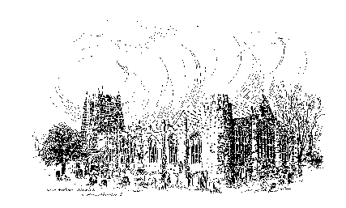

Sunday, 15th January 2023
THE SECOND SUNDAY AFTER EPIPHANY
A warm welcome to our worship today.
We hope you will stay for tea/coffee after the 10.00am service.

The wearing of a mask is a personal choice in St Michael’s

TODAY’S WORSHIP

8.30am Holy Communion (BCP)
President & Preacher : The Reverend Canon Peter Askew
10.00am Parish Communion
President & Preacher : The Reverend Canon Peter Askew

1 Corinthians 1 : 1 - 9
Isaiah’s vision of the Lord revealing himself is echoed in this opening greeting from Paul’s letter to Corinth. He gives thanks for the spiritual gifts they have received and shows himself confident that God will strengthen them for the new day of the Lord’s appearing.

John 1 : 29 – 42
John the Baptist is given an epiphany of who Jesus really is and declares his own task to be revealing Jesus. So he directs others to follow Jesus, and some men begin to recognise the Messiah.

HYMNS 10.00am
650 Great is thy faithfulness
324 Jesus calls us: o'er the tumult
421 All for Jesus, all for Jesus
510 Will you come and follow me

For your prayers this week...

First of all, a poem by Howard Thurman
When the song of the angels is stilled,
when the star in the sky is gone,
when the kings and princes are home,
when the shepherds are back with the flocks,
then the work of Christmas begins:
to find the lost,
to heal those broken in spirit,
to feed the hungry,
to release the oppressed,
to rebuild the nations,
to bring peace among all peoples,
to make a little music with the heart…
And to radiate the Light of Christ,
every day, in every way, in all that we do and in all that we say.
Then the work of Christmas begins.
And so we pray:
“to find the lost”
Shepherd God, who protects the flock and searches tirelessly for those who wander from the fold, retrieve the lost and bring them home.
“to heal those broken in spirit”
Loving God, wrap your loving arms around those who are broken-hearted, depressed, or feeling that no one cares about them, and fill their hearts with your peace, joy, and love.
“to feed the hungry”
Faithful God, we pray for everyone who is hungry today, both far away and in our local communities. We give thanks for the generosity of those giving to charity and to food banks.
“to release the oppressed”
Almighty God, who has created us in your own image, give us grace to fearlessly fight against evil and never to accept oppression; help us to use our freedom to work for justice in our communities and throughout the world.
“to rebuild the nations” and “to bring peace among all peoples”
Creator God we pray for those countries that are being torn apart by war and terrorism. We ask you to bring about changes that would bring peace and restoration, for both populations and cities alike, especially in the Ukraine war.
“to make a little music with the heart”
Father God we especially pray for our own calling and role in doing the true work of Christmas. May we be the ones who radiate the Light of Christ, every day, in every way, in all that we do and in all that we say. AMEN.

THE WEEK AHEAD
Tuesday, 17th
7.00pm St Michael’s Bowls Club in the Parish Hall
Wednesday, 18th
9.30am Holy Communion (Please note different time)
11.00am Funeral of Sarah Louise Hedley
6.00pm Week of Prayer for Christian Unity - St James’s Church
Thursday, 19th
9.30am Mini Michael’s
11.00am Week of Prayer for Christian Unity - Methodist Church
Friday, 20th
11.00am Week of Prayer for Christian Unity – Salvation Army
Saturday 21st
11.00am Week of Prayer for Christian Unity – St Paul’s Church
11.00am Messy Church
Sunday, 22nd THE THIRD SUNDAY AFTER EPIPHANY
8.30am Holy Communion
President : Reverend Martin Roff / Preacher : John Cooke
10.00am Parish Communion
President & Preacher : Bishop Mark
6.00pm Week of Prayer for Christian Unity – St James’s Church, Shilbottle - ‘SONGS OF PRAISE’

LOOKING AHEAD
Monday, 23rd
6.00pm Week of Prayer for Christian Unity – Baptist Church
Tuesday, 24th
6.00pm Week of Prayer for Christian Unity – Society of Friends (in St James’s Church, Alnwick)
7.00pm St Michael’s Bowls Club in the Parish Hall
Wednesday, 25th
10.15am Holy Communion
6.00pm Week of Prayer for Christian Unity – St Michael’s
Thursday, 26th
9.30am Mini Michael’s
Saturday 28th
12.30pm Wedding of Richard Brownlee and Jessica Robinson
*(See below)

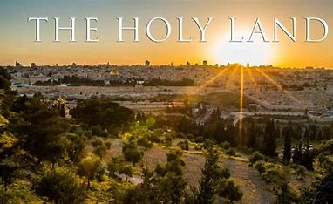
THE HOLY LAND - Lent 2024
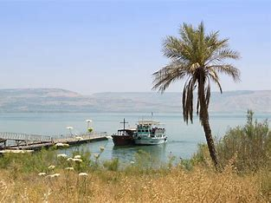
Following our successful holiday/pilgrimage to Austria and the Oberammergau Passion Play, for those of you who may be interested, Philip and I are leading a pilgrimage to the Holy Land, 4 – 11 March 2024, based in Jerusalem and Galilee. We would love you to join us. To register your interest, please let us know soonest and we can make sure you are included in the booking information mailing. Thank you. Fr Robert

*Invitation to Wedding Service 12.30pm Saturday, 28th January
Richard and Jess have felt very welcome at St Michael's, and would be very happy for you to attend their wedding service here, especially if you are a good singer!

Churchwardens
Pat Taylor Anne Blades
: 01665 603811 : 01665 602020

Parish Website: www.alnwickanglican.com
If you are a UK taxpayer, St. Michael’s can benefit to the tune of 25p for each £1.00 donated by Gift Aid. Please use the envelopes available at the back of church.
Thank you.
The Parish of St. Michael & St. Paul is a Registered Charity, No. 1131297

