THE PARISH CHURCH OF ST MICHAEL, ALNWICK

‘ALL ARE WELCOME IN THIS PLACE’
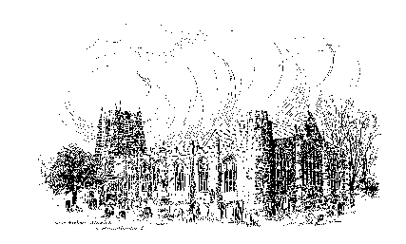

Sunday, 25th DECEMBER 2022
CHRISTMAS DAY
A warm welcome to our worship today.

The wearing of a mask is a personal choice in St Michael’s

TODAY’S WORSHIP

10.00am Parish Communion
President & Preacher : The Reverend Canon Philip Bourne

Isaiah 9 : 2,6-7
The Bible readings in Advent have prepared us to celebrate the coming of the Lord. His people longed for him, and we know the joy of living with him here and now. So, we understand Isaiah’s prophecy as greeting the birth of a child whose new kingdom of righteousness will last for ever.

Luke 2 : 1-7
&
Luke 2 : 8-16
Luke, the master storyteller, gives us pictures we shall never forget, of the humble birth at Bethlehem of the Saviour of the world, and the shining glory which brought shepherds to worship the Lamb of God.

HYMNS
61 Christians, awake! salute the happy morn
62 Come and join the celebration
60 Away in a manger, no crib for a bed
78 O come, all ye faithful
72 Joy to the world, the Lord is come!

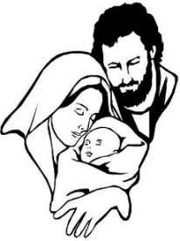
On Christmas day the Word made flesh comes to us as a child, born in a feeding-trough in Bethlehem but is yet alive and on the altar and in our hearts.

During Christmas, please pray…

… for God’s blessing on the Church as it worships together throughout the world. For our Parish Priest designate, the Reverend Christian Mitchell (Mitch) and his family as they prepare to leave Sussex and move to Alnwick.
… for the needs of the world, remembering especially those whose celebrations are tempered with sorrow or fear. As we remember
the homeless Holy family, we pray for those who have no shelter and
face eviction; for the homeless and for the institutions working to help them.

As we remember the fleeing of Jesus’ family into Egypt, we are reminded of those who are forced to flee from their homes and possessions, refugees and asylum seekers remembering particularly those from Ukraine, Afghanistan,
Syria and South Sudan.
Pray, too for the land of the Holy One and for all who live today in Bethlehem.

At Christmas we are reminded that hope comes in unexpected ways and in unfamiliar places; pray for those who find it difficult to be hopeful at Christmas, for those who suffer and for those who mourn.
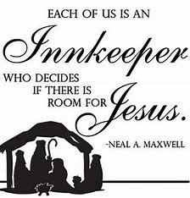
O sweet Child of Bethlehem, grant that we may
share with all our hearts in this profound mystery
of Christmas. Put into the hearts of men and
women this peace for which they sometimes seek
so desperately and which you alone can give to
them. Help them to know one another better, and
to live as brothers and sisters, children of the same
Father. Reveal to them also your beauty, holiness and purity.
Awaken in their hearts love and gratitude for your infinite goodness.
Join them all together in your love and give us your heavenly peace
in Christ, our Lord. Amen.

THE WEEK AHEAD
Thursday, 29th
11.00am Funeral of James Valentine Leck
Friday, 30th
10.00am Funeral of Jacqueline Brown
Sunday, 1st January SECOND SUNDAY OF CHRISTMAS
10.00am Parish Communion
President & Preacher : The Reverend Martin Roff

LOOKING AHEAD
Tuesday, 3rd
7.00pm St Michael’s Bowls Club in the Parish Hall
Wednesday, 4th
10.15am Holy Communion

Date change for January's First Sunday Eucharist, to January 8th.
This is a more informal service, with plenty of participation. It will be held on January 8th, not 1st January, and the subject will be 'Epiphany Surprises'.

Church Flowers for 2023
If you would like to sponsor flowers for a special occasion next year the rota will be on the sidesmen's table at the back of church for the next couple of weeks or please speak to Lynne or Pat.
Thank you
THE HOLY LAND - Lent 2024
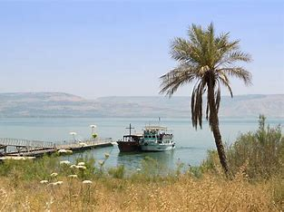
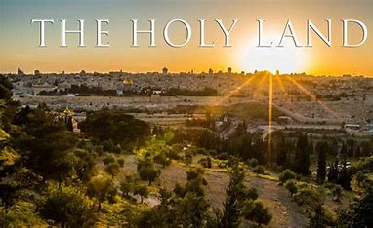
Following our successful holiday/pilgrimage to Austria and the Oberammergau Passion Play, for those of you who may be interested, Philip and I are leading a pilgrimage to the Holy Land, 4 – 11 March 2024, based in Jerusalem and Galilee. We would love you to join us. To register your interest, please let us know soonest and we can make sure you are included in the booking information mailing. Thank you.
Fr Robert
A big thank you to Morrison’s, who donated the oranges for yesterday’s Christingle Service.

Fr Robert and Fr Philip thank you for your
Christmas cards and wish you all a very
Happy Christmas and God’s richest blessings
in the New Year

Churchwardens
Pat Taylor Anne Blades
: 01665 603811 : 01665 602020

Parish Website: www.alnwickanglican.com
If you are a UK taxpayer, St. Michael’s can benefit to the tune of 25p for each £1.00 donated by Gift Aid. Please use the envelopes available at the back of church.
Thank you.
The Parish of St. Michael & St. Paul is a Registered Charity, No. 1131297

