THE PARISH CHURCH OF ST MICHAEL, ALNWICK

‘ALL ARE WELCOME IN THIS PLACE’
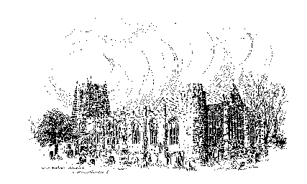

Sunday, 1st January 2023
THE SECOND SUNDAY OF CHRISTMAS
A warm welcome to our worship today.
We hope you will stay for tea/coffee after the 10.00am service.

The wearing of a mask is a personal choice in St Michael’s

TODAY’S WORSHIP

10.00am Parish Communion
President & Preacher : The Reverend Martin Roff

Hebrews 2 : 10 - 18
This unknown writer explains that because God in Christ shared all the experiences we humans suffer, he is able to bring us with him into the Father’s glory.

Matthew 2 : 13 - 23
We shall hear at Epiphany-tide how important men from the East paid homage to the infant Christ. Today’s Gospel tells a harsher tale, of Herod’s fury at the possibility of a rival king. So the Holy Family become refugees, until the time when it will be safe to return.

HYMNS
59 Angels from the realms of glory
88 What child is this, who, laid to rest
87 Thou who wast rich beyond all splendour
715 Lord, for the years your love has kept and guided

Gracious God, at the start of a new year we bring you our hopes for the world and for its peoples.

Grant us peace in place of strife,
a desire for justice instead of a dash for growth,
the building up of forests not their pulling down,
the cleansing not the pollution of our seas,
and goodwill in place of hatred.

Lord, this year will bring its share of illness and bereavement and family conflict, as well as other personal challenges and difficulties.
We pray now for those who already face these trials.
May they know your healing and hope,
your guidance and your power to save,
and the good news of Jesus Christ
who is Lord of this life and of the life to come;
our brother who is human like us,
yet picks up our frail bodies and takes us with him into life eternal.
May his Spirit bear witness to these things,
to what you are doing in others' lives and ours.

Lord, we take a minute to reflect on what lies ahead for each one of us,
and to ask for your help and blessing.
(Pause for reflection...)

Lord God,
one day we will see all things gathered up in Jesus Christ:
may we live now and always in the light and love of that.
Be alongside us and all your people everywhere,
each and every day of this new year.
Amen.

THE WEEK AHEAD
Tuesday, 3rd
7.00pm St Michael’s Bowls Club in the Parish Hall
Wednesday, 4th
10.15am Holy Communion
Sunday, 8th THE FIRST SUNDAY AFTER EPIPHANY
10.00am First Sunday Eucharist
President & Preacher : The Reverend Canon Sue Allen
2.00pm Baptism of Alby Miller-Murphy
6.00pm Deanery Evensong

LOOKING AHEAD
Tuesday, 10th
7.00pm St Michael’s Bowls Club in the Parish Hall
Wednesday, 11th
10.15am Holy Communion
Thursday, 12th
9.30am Mini Michael’s

Date change for January's First Sunday Eucharist, to January 8th.
This is a more informal service, with plenty of participation. It will be held on January 8th, not 1st January, and the subject will be 'Epiphany Surprises'.

Church Flowers for 2023
If you would like to sponsor flowers for a special occasion next year the rota will be on the sidesmen's table at the back of church for the next couple of weeks or please speak to Lynne or Pat.
Thank you
THE HOLY LAND - Lent 2024
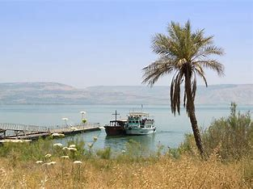
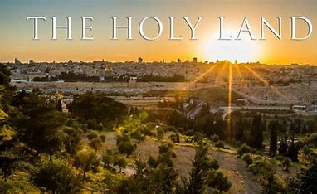
Following our successful holiday/pilgrimage to Austria and the Oberammergau Passion Play, for those of you who may be interested, Philip and I are leading a pilgrimage to the Holy Land, 4 – 11 March 2024, based in Jerusalem and Galilee. We would love you to join us. To register your interest, please let us know soonest and we can make sure you are included in the booking information mailing. Thank you.
Fr Robert

Churchwardens
Pat Taylor Anne Blades
: 01665 603811 : 01665 602020

Parish Website: www.alnwickanglican.com
If you are a UK taxpayer, St. Michael’s can benefit to the tune of 25p for each £1.00 donated by Gift Aid. Please use the envelopes available at the back of church.
Thank you.
The Parish of St. Michael & St. Paul is a Registered Charity, No. 1131297

