**THE PARISH CHURCH OF ST MICHAEL, ALNWICK**

**‘ALL ARE WELCOME IN THIS PLACE’**

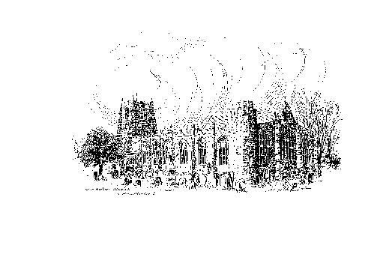

**Sunday, 27th NOVEMBER 2022**

**ADVENT SUNDAY**

**A warm welcome to our worship today.**

**We hope you will stay for tea/coffee after the 10.00am service.**

*The wearing of a mask is a personal choice in St Michael’s*

**TODAY’S WORSHIP**

**8.30am Holy Communion**

*President & Preacher : The Reverend Martin Roff*

**10.00pm Parish Communion**

*President & Preacher : The Reverend Martin Roff*

**Romans 13 : 11 – 14**

Isaiah and all Israel expected a new age of the Messiah. For Paul’s readers as for us, the new time has come – not yet in its fullness, but begun in the coming of Jesus Christ. Our behaviour must therefore be suitable to these decisive times, nearer every day to the Christ who will come again.

**Matthew 24 : 36 – 44**

In this new church year, the Gospel on most Sundays will be from that of Matthew. Here, Jesus has some warnings for his disciples about the final coming of the Son of Man. His kingdom will mean a separation between those who are expectant and those left unprepared. God may refuse those who eternally refuse him.

**Hymns at 10.00am**

54 Wake, O wake!

30   Come, thou long-expected Jesus

47   People, look east

41 Lo, he comes with clouds descending

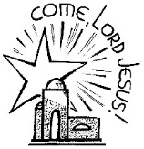**In your prayers this week, please** …

… give thanks to God for the strength of Christian community which warms our hearts.

Enable us this Advent to refocus, renew and revitalize our commitment to you and to the building up of your Kingdom in this place.

… pray that we may be less absorbed by the present and ourselves

that we may raise our eyes beyond.

… pray for God’s blessing on the local community; pray for warmth

for those feeling the cold, and for long- and short-term solutions to the

energy crisis enabling everyone to live well.

… pray for those who rely on foodbanks to get the essentials they need.

For charities and community groups who provide these services which are struggling to keep up with the demand.

… pray for those suffering at the hands of others.

**God of hope and promise, be with us throughout this Advent season**

**and draw us ever closer as we journey together towards the stable and**

**the birth of your Son, our Saviour. Amen**

**THE WEEK AHEAD**

***Tuesday, 29th***

7.00pm St Michael’s Bowls Club in the Parish Hall

***Wednesday, 30th***

10.15am Holy Communion

***Thursday, 1st December***

9.30am Mini Michael’s

***Saturday, 3rd***

7.30pm Northern Sinfonia ‘Christmas by Candlelight’

***Sunday, 4th SECOND SUNDAY OF ADVENT***

10.00pm First Sunday Eucharist

*President & Preacher : The Reverend Canon Sue Allen*

2.00pm Baptism of Scarlett Carr

6.00pm Deanery Evensong

**LOOKING AHEAD**

***Tuesday, 6th***

7.00pm St Michael’s Bowls Club in the Parish Hall

7.00pm PCC Meeting in Parish Hall

***Wednesday, 7th***

10.15am Holy Communion

***Thursday, 8th***

9.30am Mini Michael’s

**THIS WEEK’S ECO TIP**

**Wrapping**

(The following is very obvious but worth including just in case it might be helpful to someone.)

When wrapping several gifts, start by cutting off the paper you need for the biggest present. Working down from large to small there is every possibility that the ‘leftovers’ from the bigger shapes will fit the smaller ones perfectly, (and it is one of life’s little joys when they do :)

**Angels, stars and …..doves!**

In 2020 hundreds and hundreds of hand knitted angels were left all over Alnwick for anyone and everyone to take home and feel a little cheered in what had been a difficult year. In 2021 the theme was stars. This year we are hoping to be able to leave paper doves in their little (biodegradable!) cellophane bags, complete with greeting, on seats and fences, walls and lamp posts throughout the town. Please do look at the examples at the back of church and take home a sheet of instructions. (Only cutting and sticking skills required this year!). Thank you.

Sue Wiltshire and Michelle Duff on behalf of CTiA

The Diocese have offered a daily **source of inspiration during Advent**. If you are interested the link is - <https://thevcs.org/Advent2022>

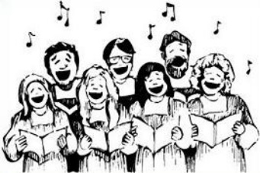**ST MICHAEL’S CAROL SERVICE – CALLING ALL SINGERS!**

We’d love you to be part of St Michael’s Singers at the

Carol Service on Sunday, 18th December at 6.00pm.

We are recruiting and need you - no experience needed!

For more details, please speak to Robert or Philip asap. Thank you.

**Churchwardens**

**Pat Taylor Anne Blades**

**🕾 :** 01665 603811 **🕾 :** 01665 602020

**Parish Website:** [**www.alnwickanglican.com**](http://www.alnwickanglican.com)

If you are a UK taxpayer, St. Michael’s can benefit to the tune of 25p for each £1.00 donated by Gift Aid. Please use the envelopes available at the back of church.

Thank you.

The Parish of St. Michael & St. Paul is a Registered Charity, No. 1131297