**THE PARISH CHURCH OF ST MICHAEL, ALNWICK**

**‘ALL ARE WELCOME IN THIS PLACE’**

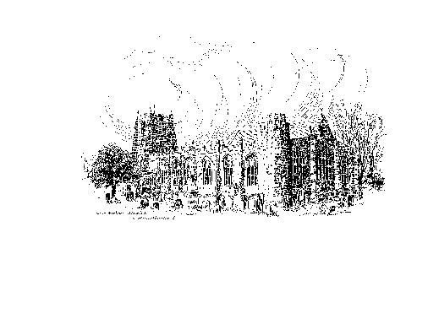

**Sunday, 18th SEPTEMBER 2022**

**FOURTEENTH SUNDAY AFTER TRINITY**

**A warm welcome to our worship today.**

**We hope you will stay for tea/coffee after the 10.00am service – but please try to gather in groups of no more than six.**

*The wearing of a mask is a personal choice in St Michael’s*

**TODAY’S WORSHIP**

**8.30am Holy Communion (BCP)**

*President & Preacher : The Reverend Canon Dr Philip Bourne*

**10.00am Parish Communion**

*President & Preacher : The Reverend Robert Chavner, TSSF*

**2.00pm Battle of Britain Service**

**6.00pm Said Evensong**

*Officiant : John Cooke*

**1 Timothy 2 : 1 – 7**

In phrases that were probably part of an early Christian liturgy, the church is called to prayer for the peace of the world and its leaders, because God’s will is salvation for all.

**Luke 16 : 1 – 13**

This parable seems to praise dishonesty, but we must hear it as a challenge to perceive where our best interests lie, and to pursue the truest good.

**HYMNS AT 10.00am**

766 Praise, my soul, the King of heaven

799 The Lord's my Shepherd, I'll not want

787 Take my life, and let it be consecrated, Lord, to thee

541 Lord of beauty, thine the splendour

**HYMNS AT 6.00pm**

621 Dear Lord and Father of mankind

579 I vow to thee, my country, all earthly things above

752 O love that wilt not let me go

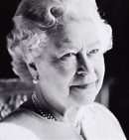

**Her Majesty Queen Elizabeth the Second 1926 - 2022**

Rest eternal grant to your servant Elizabeth and let light perpetual shine upon her.

*Gracious God we give thanks for the life of your servant Queen Elizabeth, for her faith and her dedication to duty.*

*Bless our nation as we mourn her death and may her example continue to inspire us; through Jesus Christ our Lord. Amen.*

***Please pray ...***

... for the King and Queen Consort and all the Royal Family as they mourn the loss of a mother and grandmother as well as a friend and monarch.

... for political leaders and especially the British nation at a time of change.

... for the Prime Minister and Party Leaders as they negotiate the political future of the nation.

... for God’s Church, for the clergy and our churchwardens and for the love that unites us.

... for all those in need; those suffering from violence, injustice, hunger and the effects of climate change.

... for this planet earth and our stewardship of its resources.

Every creature, every plant, every rock and grain of sand  
proclaims the glory of its Creator,

worships through colour, shape,  
scent and form. A multi-sensory song of praise.  
Creator God, may we join with the whole of your creation,  
in praising you, our Creator, through the fragrance  
and melody of our lives.

Through Jesus Christ our Lord. Amen.

**THE WEEK AHEAD**

***Tuesday, 20th***

7.00pm St Michael’s Bowls Club in the Parish Hall

***Wednesday, 21st***

10.15am Holy Communion

***Thursday, 22nd***

9.30am Mini Michael’s

***Sunday, 25th  THE FIFTEENTH SUNDAY AFTER TRINITY***

8.30am Holy Communion

*President & Preacher : The Reverend Martin Roff*

10.00am Parish Communion

*President & Preacher : The Reverend Martin Roff*

2.00pm Baptism of Anya Paterson

6.00pm Iona Style Evening Prayers

*Officiant : Annette Playle*

**LOOKING AHEAD**

***Tuesday, 27th***

7.00pm St Michael’s Bowls Club in the Parish Hall

***Wednesday, 28th***

10.15am Holy Communion

***Thursday, 29th***

9.30am Mini Michael’s

**THIS WEEK’S ECO TIP**

**Clothes – a final word.**  When clothes are made ‘ethically’ i.e. when wages have been fair throughout the supply chain, when sustainable fabric has been used, when pollution from dyes and the carbon footprint has been kept to a minimum, clothes are more expensive. When we pay these higher prices we are paying the true cost. Most of us have limited funds which is why the advice from Ethical Consumer is worth taking to heart;

**‘Buy fewer clothes, preferably buy second-hand; ,**

**recycle and upcycle and if you need to buy new, buy ethical brands.**

(Ethical Consumer is an independent, not for profit organisation which researches and publishes facts and figures around the sustainability of over 40,000 items to help the consumer make informed choices, [www.ethicalconsumer.org](http://www.ethicalconsumer.org/). Reader may also like to google ‘sustainable fashion on the UK hight street’ for information around the steps that well known brands are taking to become ‘greener’.

N.B. Where once there was only a handful of brand names associated with producing sustainable clothes, e.g. People Tree, Thought, Traidcraft, a quick internet search will now bring up many, many more.

We are going to have a **BIG CLEAN** in church on Saturday, 1st October. Help would be gratefully received from anyone who can spare an hour that morning. Refreshments will be provided.

We are looking for two people to act as Churchwardens from next

March 2023.

If you are interested, please speak to one of the Wardens, John Cooke or Annette Playle.

**Churchwardens**

**Pat Taylor Anne Blades**

**🕾 :** 01665 603811 **🕾 :** 01665 602020

**Parish Website:** [**www.alnwickanglican.com**](http://www.alnwickanglican.com)

If you are a UK taxpayer, St. Michael’s can benefit to the tune of 25p for each £1.00 donated by Gift Aid. Please use the envelopes available at the back of church. Thank you.

The Parish of St. Michael & St. Paul is a Registered Charity, No. 1131297