THE PARISH CHURCH OF ST MICHAEL, ALNWICK

‘ALL ARE WELCOME IN THIS PLACE’
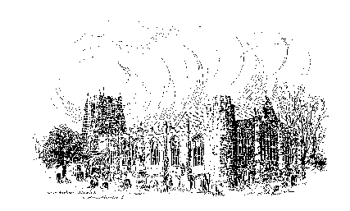

Sunday, 28th AUGUST 2022
ELEVENTH SUNDAY AFTER TRINITY

A warm welcome to our worship today.
We hope you will stay for tea/coffee after the 10.00am service – but please try to gather in groups of no more than six.

The wearing of a mask is a personal choice in St Michael’s

TODAY’S WORSHIP

8.30am Holy Communion
President & Preacher : The Reverend Canon Dr Philip Bourne
10.00am Parish Communion
President : The Reverend Martin Roff
Preacher : The Reverend Canon Dr Philip Bourne
2.00pm Baptism of Arlo Baxter
6.00pm Compline
Officiant : Annette Playle

Hebrews 13 : 1 - 8, 15 - 16
This essay, complex in many ways, ends simply with some specific instructions about the Christian way of life, which gives praise to God in both word and deed.

Luke 14 : 1, 7 - 14
Jesus’s parable is a stern lesson not to think too highly of ourselves but to copy his humility – and also, like him, give our greatest concern to those in greatest need.

HYMNS AT 10.00am
691 Jesus shall reign where'er the sun
602 Blest are the pure in heart
741 O Christ the same, through all our story's pages
494 I, the Lord of sea and sky

HYMNS AT 6.00pm
358 Be still, for the presence of the Lord
794 The King of love my shepherd is

For your prayers this week...
- for the Church: that she may speak words of truth and justice, act with compassion, and be a sign of Christ’s love for all those who are suffering.
- for world leaders, that guided by integrity and wisdom they may work together so that peace may flourish.
- for all those caught up in violence, remembering especially the people of Ukraine; that in this time of fear and conflict, they may know God’s presence and peace.
- for all those suffering from hunger as a result of conflict and injustice, including those in Sierra Leone, Afghanistan and Ethiopia.
- for our parish and our local community: that we may reach out in solidarity to our brothers and sisters in need.
- for our churchwardens, other members of the Parochial Church Council, and for each one of us as we play our part in the life and ministry of St Michael's Church.

THE WEEK AHEAD
Tuesday, 30th
1.30pm Funeral of Kevin Forster
Wednesday, 31st
10.15am Holy Communion

Sunday, 4th September THE ELEVENTH SUNDAY AFTER TRINITY
8.30am Holy Communion
President & Preacher : The Reverend Colin Perkins
10.00am First Sunday Eucharist
President & Preacher : The Reverend Canon Sue Allen
6.00pm Deanery Evensong
LOOKING AHEAD
Tuesday, 6th
7.00pm PCC Meeting
Wednesday, 7th
10.15am Holy Communion
12 noon Funeral of John Davidson
Thursday, 8th
9.15am Mini Michael’s

THIS WEEK’S ECO TIP
Clothes The fashion industry is the second most polluting industry in the world. Sadly, even among the brands which claim to be cutting their emissions year on year, there is a great deal of ‘green washing’ practised to hide the true facts. The industry must change and in the meantime the best advice for the consumer is to simply buy less. Repair and rethink what is already in your wardrobe and buy second hand as much as possible. When a brand new article is essential, buy the very best quality you can afford.

We are looking for two people to act as Churchwardens from next
March 2023.
If you are interested, please speak to one of the Wardens, John Cooke or Annette Playle.

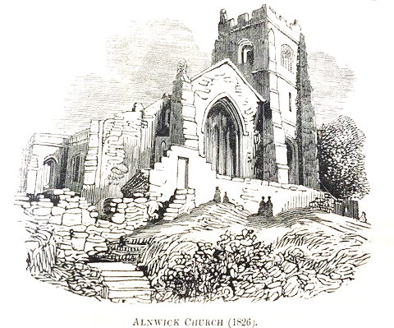

Churchwardens
Pat Taylor Anne Blades
: 01665 603811 : 01665 602020

Parish Website: www.alnwickanglican.com

If you are a UK taxpayer, St. Michael’s can benefit to the tune of 25p for each £1.00 donated by Gift Aid. Please use the envelopes available at the back of church. Thank you.
The Parish of St. Michael & St. Paul is a Registered Charity, No. 1131297

