THE PARISH CHURCH OF ST MICHAEL, ALNWICK

‘ALL ARE WELCOME IN THIS PLACE’
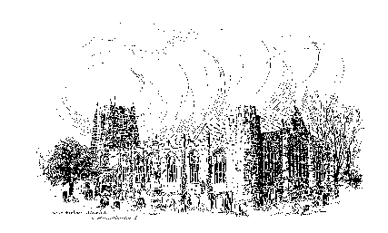

Sunday, 21st AUGUST 2022
TENTH SUNDAY AFTER TRINITY

A warm welcome to our worship today.
We hope you will stay for tea/coffee after the 10.00am service – but please try to gather in groups of no more than six.

The wearing of a mask is a personal choice in St Michael’s

TODAY’S WORSHIP

8.30am Holy Communion (BCP)
President/Preacher : The Reverend Colin Perkins/Annette Playle
10.00am Parish Communion
President/Preacher : The Reverend Martin Roff/Annette Playle
6.00pm Said Evensong
Officiant : John Cooke
Hebrews 12 : 18 – 29
On recent Sundays we have heard this writer praising the saints of ancient times, while drawing a contrast between their faith and ours. Unlike them, he says, we come to God through Jesus without fear, in reverence and awe and thanksgiving.
Luke 13 : 10 – 17
Jesus’s ministry was to teach and to heal. On a Sabbath day, he was permitted to teach, but the synagogue President objected to him healing a crippled woman. Jesus responds with a sharp lesson about priorities.
HYMNS AT 10.00am
698 King of glory, King of peace
667 I danced in the morning when the world was begun
632 Fill thou my life, O Lord my God
510 Will you come and follow me
HYMNS AT 6.00pm
669 I heard the voice of Jesus say
584 All my hope on God is founded
24 The day thou gavest, Lord, is ended

For your prayers this week ...

... for the Peace of the world ...
... for those living through change and difficult circumstances ...
... for Alnwick and her peoples and for those preparing for the Sacraments of Baptism and Marriage ...
... for our parish in vacancy and for wisdom in the appointment of a new priest at St Michael's ...
... for all those who are in any kind of need ...
... for those who have died and those who grieve for them ...

THE WEEK AHEAD
Wednesday, 24th
10.15am Holy Communion
Thursday, 25th
10.00am Mini Michael’s helpers’ meeting (See over)
Saturday, 27th
10.00am Market Stall
Sunday, 28th THE ELEVENTH SUNDAY AFTER TRINITY
8.30am Holy Communion
President & Preacher : The Reverend Canon Dr Philip Bourne
10.00am Parish Communion
President : The Reverend Martin Roff
Preacher : The Reverend Canon Dr Philip Bourne
2.00pm Baptism of Arlo Baxter
6.00pm Compline
Officiant : Annette Playle
LOOKING AHEAD
Wednesday, 31st
10.15am Holy Communion
MINI MICHAEL’S There will be a Meeting for Mini Michael’s helpers on Thursday, 25th August at 10.0am in Church, to prepare for the new term. Alan Craig
THIS WEEK’S ECO TIP
Gadgets continued – leaving things on standby
The newer the appliance, whether it be a TV, music system, microwave or whatever, the less power it is likely to use when left on standby. (The cost of running an up-to-date TV for a year on standby is about £1). Older appliances will use more energy. While the figures we are considering are small, many households will have things constantly running, year in, year out. Multiply this by millions of homes and obviously it has a significant impact. Switch off what you can, (at the mains), paying special attention to items in rooms that are not in constant use.

MARKET STALL We are having a Market Stall on Saturday, 27th August. These stalls create an excellent fundraising and outreach opportunity for St Michael’s.
Please help to make sure the stall is well stocked for these dates. All things homemade, jams, baking, crafts and knitted items are needed. Please let us know if you need anything collected. Also, if you could spare a couple of hours to help man the stall, please speak to Anne or Pat.

FLOWER FESTIVAL The total raised over the four days of the festival was £1,881.12. This means that both St Paul’s and St Michael’s benefit to the tune of £940.56.
A brilliant result for both churches.

We are looking for two people to act as Churchwardens from next
March 2023.
If you are interested, please speak to one of the Wardens, John Cooke or Annette Playle.

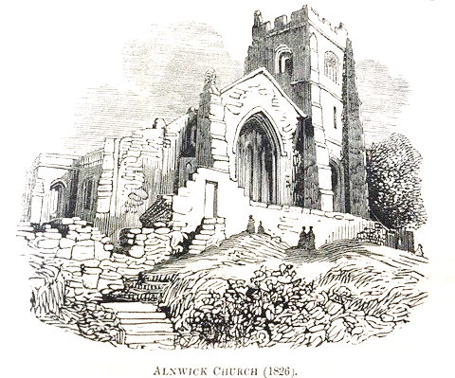

Churchwardens
Pat Taylor Anne Blades
: 01665 603811 : 01665 602020

Parish Website: www.alnwickanglican.com

If you are a UK taxpayer, St. Michael’s can benefit to the tune of 25p for each £1.00 donated by Gift Aid. Please use the envelopes available at the back of church. Thank you.
The Parish of St. Michael & St. Paul is a Registered Charity, No. 1131297

