THE PARISH CHURCH OF ST MICHAEL, ALNWICK

‘ALL ARE WELCOME IN THIS PLACE’
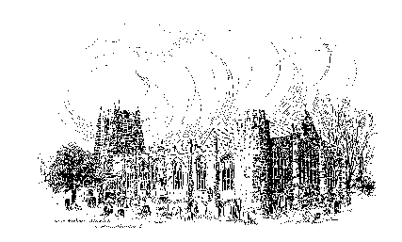

Sunday, 3rd JULY 2022
THIRD SUNDAY AFTER TRINITY

A warm welcome to our worship today.
We hope you will stay for tea/coffee after the 10.00am service – but please try to gather in groups of no more than six.

The wearing of a mask is a personal choice in St Michael’s

TODAY’S WORSHIP

8.30am Holy Communion
President & Preacher : The Reverend Colin Perkins
10.00am First Sunday Eucharist
President : The Reverend Robert Chavner TSSF
Preacher : The Reverend Canon Dr Philip Bourne
6.00pm Deanery Evensong (BCP)

Ephesians 2: 19 - End
John 20: 24 - 29

HYMNS AT 10.00am
227 Crown him with many crowns
389 Spirit of God, unseen as the wind
622 Dear Lord, we long to see your face
719 Lord, the light of your love is shining
HYMNS AT 6.00pm
299 Give us the wings of faith to rise
213 O sons and daughters, let us sing!
When Thomas heard from Jesus

DURING THIS WEEK PLEASE PRAY …
… for the places in our world where war is raging, including Ukraine, Myanmar, Afghanistan, Yemen and Ethiopia. Pray for peace, and for all world leaders to use their powers to work for peace, justice and truth. Pray for all the innocent people affected by conflict, that they will be treated with compassion and respect.
… for all who suffer at this time, especially as a result of natural disasters
and accidents. Pray for the refugees and the homeless, the hungry
and the thirsty, the sick and the injured. Pray that they will receive
the help, support and encouragement they need, particularly from
local and international government structures as well as aid
organisations.
… for the worldwide Christian community and for the generations of faithful Christian servants, from the first apostles and followers to our own congregations today. Pray that the Holy Spirit continues to guide, strengthen and inspire all God's people around the world, wherever they may be and whatever circumstances they find themselves in, to live as God's servants and witnesses.

THE WEEK AHEAD
Tuesday 5th
7.00pm PCC Meeting in church
Wednesday, 6th
10.15am Holy Communion
10.30am Coffee Morning at home of Michelle Duff
Thursday, 7th
9.30am Mini Michael’s
Sunday, 10th THE FOURTH SUNDAY AFTER TRINITY
8.30am Holy Communion
President & Preacher : The Reverend Martin Roff
10.00am Parish Communion
President & Preacher : The Reverend Martin Roff
6.00pm Iona Style Evening Prayers & Address
Officiant : John Cooke

LOOKING AHEAD
Tuesday, 12th
10.00am – Graffiti Project - Community Drop-In Day
4,30pm
Wednesday, 13th
10.15am Holy Communion
2.00pm Mothers’ Union meet in church
7.30pm Following in the Footsteps of St Aidan (see overleaf)
Thursday, 14^{h}
9.30am Mini Michael’s
Saturday, 16th
2.00pm Wedding of Alex Tully and Samantha Robinson

CRAFT TABLE
Calling all crafters and knitters.
As we get back to normal lots of holiday makers are visiting church and buying from our craft table, together with our usual customers from Mini Michaels etc. We are therefore needing more goods to sell. Can you help? Small knitted or crocheted goods, children’s knitwear and jams and preserves all sell well and any new handmade ideas will add to our stall and would be very welcome. If you need any more information please speak to Anne, Pat or Eve. Many thanks.

THIS WEEK’S ECO TIP
A plastic watering can with a hole or crack can be mended in moments with a little melted candle wax. Having dripped the wax as closely as possible to where it is needed, spread it quickly into place with a piece of very stiff cardboard or an old lolly pop stick. Works a treat.

COFFEE MORNING
Wednesday, July 6th from 10.30am – 12.30pm
At Michelle Duff’s house : - The Coach House, Bondgate Within
All proceeds to go toward the cost of oasis for the Flower Festival
Tea, coffee, juice and cake. £3 entrance

COMMUNITY DROP-IN DAY
On Tuesday, 12th July there is to be a Community Drop-In Day to explore the way forward for our Community Graffiti Project. Year 5 from our school will explore the St Michael’s Graffiti Mystery in the morning. A display of their work and ideas will be open to all from 2pm – 4pm. Please come and see all the possibilities it gives us to be a very visible and interactive part of the community. We will need some help to set up in the afternoon of Monday, 11th and in providing and helping with refreshments for the afternoon of the 12th.
Please contact Jean Darby if you can help in any way.

Jessica Turner will present
“FOLLOWING IN THE FOOTSTEPS OF SAINT AIDAN”
13th July, 7:30 pm at St. James Centre Pottergate
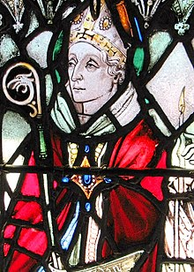
Jessica is Historic and Built Environment Officer, Northumberland Coast Area of Outstanding Natural Beauty Partnership, and Accessing Aidan Project Officer,
Bamburgh Heritage Trust.

This talk is part of the Alnwick Civic Society series, and all are welcome to attend.

Churchwardens
Pat Taylor Anne Blades
: 01665 603811 : 01665 602020

Parish Website: www.alnwickanglican.com

If you are a UK taxpayer, St. Michael’s can benefit to the tune of 25p for each £1.00 donated by Gift Aid. Please use the envelopes available at the back of church. Thank you.

The Parish of St. Michael & St. Paul is a Registered Charity, No. 1131297

