New Life in the Churchyard
There is lots of encouraging progress towards making the churchyard more welcoming for both wildlife and people.
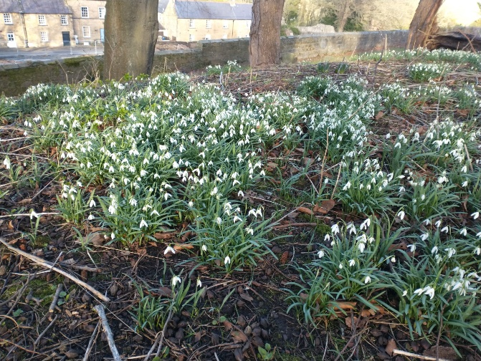
A magnificent display of snowdrops has greeted everyone walking around the north side of the church, on the far side from the main entrance.
Bulbs from previous years have been supplemented by those planted in December by church volunteers, the new wild daffodils are beginning to flower, and the bluebells are coming up.
Almost all the saplings planted by young volunteers from the Community Centre @NE66 are sprouting, and should grow to form a hedge to protect the drop beyond. The nettles from the bank are well on the way to being cleared to allow other wildflower plants to flourish in due course. These will attract insects for pollination, and to feed visiting birds. Some fallen wood has been left to provide insect nests, and plans are in hand to produce nesting boxes for birds and bats. We hope that volunteers from the wider community, as well as the church, will continue to be involved.
To make the churchyard more welcoming for people we look forward to providing more seating, especially on the sunny south side of the church. Troughs will be filled with flowers, including some that are scented.
Please look at the display board in church for updates on the progress.

