THE PARISH CHURCH OF ST MICHAEL, ALNWICK

‘ALL ARE WELCOME IN THIS PLACE’
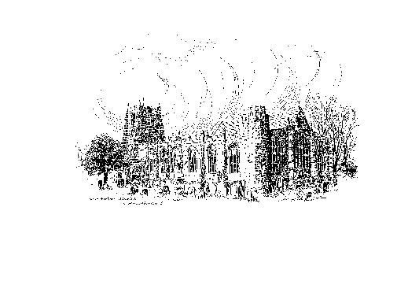
Sunday, 9th January 2022
THE FEAST OF THE EPIPHANY (TRANSFERRED)
A warm welcome to our worship today.
May you know the peace, the joy and the hope of this season
as we continue to celebrate the birth of the Christ-child

Government regulations have once again made mandatory the wearing of a face covering in church. Pews have again been taped off to create greater space and we would ask, please, that you continue to use the hand sanitizer provided on entering and leaving church.
Please note that our 10.00am service is usually live-streamed. Should you wish not to be on camera please speak to a Churchwarden who will show you to a suitable seat. Thank you.

TODAY’S WORSHIP
8.30am Holy Communion
10.00am Parish Communion
6.00pm Iona Style Evening Prayer & Address

Ephesians 3: 1-12
Riches beyond imagining, says Paul, are found in Christ. Though he is in prison for his faith, his gospel cannot be confined – the good news that God’s purposes, once so obscure, are now made clear for Jew and Gentile alike.

Matthew 2: 1-12
Only Matthew tells us how representatives of other strange religions came from the East to offer their homage to the one and only true God, the child who is king for ever over all earthly powers.
HYMNS AT 10.00am
94 As with gladness men of old
105 We three kings of Orient are
96 Brightest and best of the sons of the morning
806 There's a wideness in God’s mercy

IONA STYLE EVENING PRAYER & ADDRESS
103 O worship the Lord in the beauty of holiness
Second hymn to be announced

FOR YOUR PRAYERS
- That we may use the gifts God has given us in his service
- Those suffering from Coronavirus – and all working to support them
- Thanks for our fellowship in Christ
- Pat & Anne, our Churchwardens as the parish goes into vacancy
- All who work for peace and justice

THE WEEK AHEAD

Tuesday
7.00pm St Michael’s Bowls Club in the Parish Hall

Wednesday
10.15am Holy Communion
2.00pm Mothers’ Union is CANCELLED this month

Thursday
9.30am Mini Michaels in church

Saturday
11.00am Messy Church in church

Sunday THE SECOND SUNDAY OF EPIPHANY
8.30am Holy Communion (BCP)
10.00am Parish Communion
6.00pm Compline & Address

NEXT SUNDAY MORNING’S READINGS
1 Corinthians 12: 1-11 John 2: 1-11

LOOKING AHEAD
Wednesday 19th 7.30pm Messy Church meeting at Pat Taylor’s
Wednesday 2nd February 7.00pm PCC Meeting in church

This morning you are invited to stay behind after the 10.00am Parish Communion. This will be PAUL’S LAST SERVICE AS VICAR before retirement and a light lunch will be served.

With regret it has been decided that this week’s meeting of the MOTHERS’ UNION should be cancelled. Several of our members fall into the ‘vulnerable’ category so far as Covid is concerned and we do not want to put anyone in unnecessary danger. Here’s hoping that the situation will soon improve and we may be able to meet on 9th February.

MESSY CHURCH will take place here on Saturday 11.00am – 1.00pm. Please do let families with young children know that this is happening. Crafts, stories and lunch together all help towards a fun-filled time!

As the country is urged to take extra precautions to contain the OMICROM VERSION OF CORONAVIRUS it is important, once again, to urge people in church to observe the USE OF HAND SANITIZER AND THE WEARING OF MASKS wherever possible. SOCIAL DISTANCING has been reintroduced in the pews once again and, for the time being, we will not meet to socialise over coffee at the end of our services. We must do all we can to protect the spread of this new strain. Thank you.

HELP IN THE SEARCH FOR THE NEXT BISHOP OF NEWCASTLE. The Committee working to a tight schedule on the Diocese's input to the search would like to hear by 14 January from anyone with views on the matter. If you have views and access to the internet, please consider responding to the Committee's survey at www.surveymonkey.de/r/V9FGYVV or emailing views to vis@newcastle.anglican.org
Alternatively, views sent instead by post (by 12 January) should be addressed to: Vacancy in See Committee Secretary, Church House, St John's Terrace, North Shields, NE29 6HS or, nearer home, Richard Allsop on 01665 510095 will try to deal with queries about this.

THIS WEEK’S ECO TIP
It has been estimated that about 22% of all carbon emissions comes from our homes. A little tweaking here and there, multiplied many times over, will make a big difference.
Heating. At this time of year most of us have our heating on for at least some part of the day. Take a quick tour of your house or flat. Are there any radiators which can be turned down a little or even turned completely off?

AN EPIPHANY REFLECTION

God of GOLD, we seek your glory:
the richness that transforms our drabness into colour,
and brightens our dullness with vibrant light;
your wonder and joy at the heart of all life.

God of INCENSE, we offer you our prayer:
our spoken and unspeakable longings, our questioning of truth,
our search for your mystery deep within.

God of MYRRH, we cry out to you in our suffering:
the pain of all our rejections and bereavements,
our baffled despair at undeserved suffering,
our rage at continuing injustice;
and we embrace you, God-with-us,
in our wealth, in our yearning, in our anger and loss.

Jan Berry

Vicar: The Rev’d. Canon Paul Scott
Tel: 01665 603078
email: paulscott1957@btinternet.com

Parish Website: www.alnwickanglican.com

If you are a UK taxpayer, St. Michael’s can benefit to the tune of 25p for each £1.00 donated by Gift Aid. Please use the envelopes available at the back of church. Thank you.

The Parish of St. Michael & St. Paul is a Registered Charity, No. 1131297

