**ST. MICHAEL’S CHURCH**

**ALNWICK**

**HARVEST FESTIVAL**

**FIRST SUNDAY EUCHARIST**

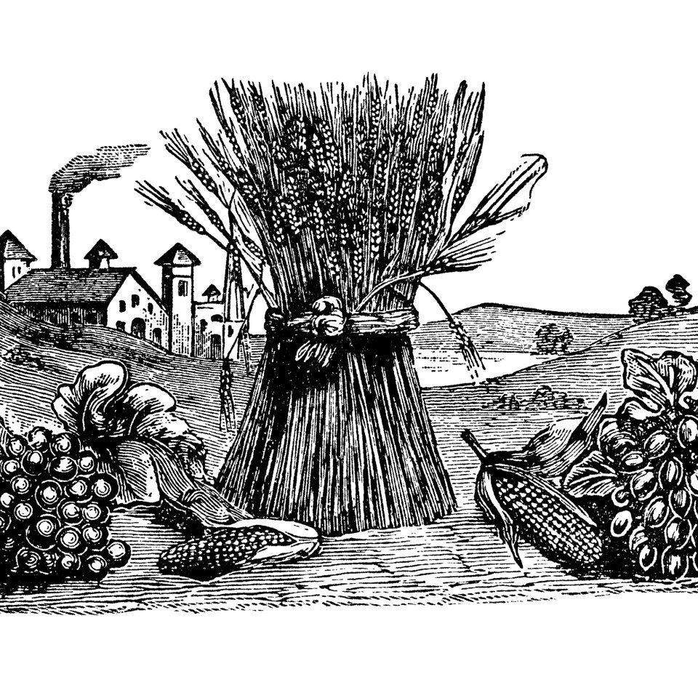

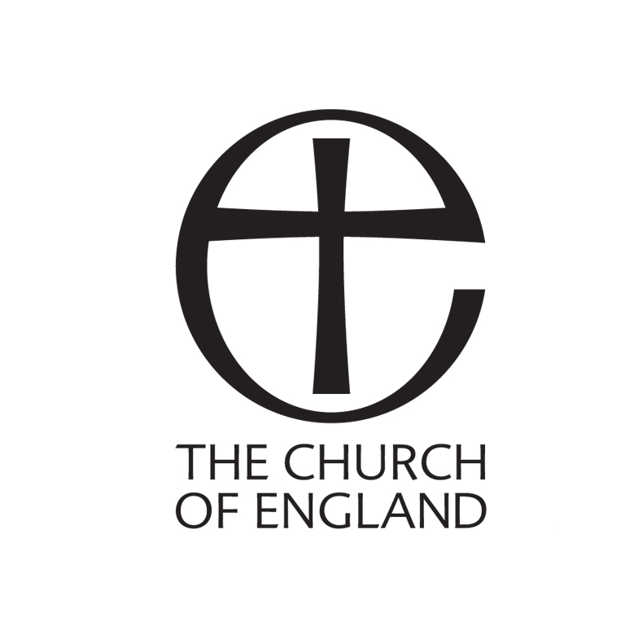

**THE EUCHARIST**

The Eucharist – which means “saying thank you” – is the central act of worship for Christians. In simple terms it allows us to meet with Jesus and helps us to understand the story of his love.

We cannot hear Jesus speaking to us today like people could when he was alive on earth – but we can hear him speak when we read or listen to the Bible.

We cannot feel Jesus holding us or blessing us as he did when he carried out his ministry two thousand years ago – but we can feel his love in other people.

We cannot experience Jesus feeding us like he fed the five thousand or shared supper with his friends – but he does feed us when we share bread and wine as he asked.

So as we gather together for this party – a very special party in which we say thank you to God for his Son – we look for Jesus to come to us in word, in sacrament and in one another.

And then we are sent back to our homes, our community, our classrooms to live our lives like Jesus. We try to speak and act like him. We try to listen and love like him. We have received a blessing; we try to be a blessing to others.

**WELCOME & INTRODUCTION**

**HYMN & SONG**

656 ‘He’s got the whole world in his hands vv 1,5,6 only.

290 ‘We plough the fields’ vv 1 and 3, with choruses.

*During the hymn those carrying items for the Opening Prayer process with them up the aisle and stand at the front.*

**OPENING PRAYER** *(we say together words in bold)*

**We praise you, living God:**

you give strength to the earth that sustains us,

you open your hand to feed all living things.

*(a bread roll is placed on the table)*

**We praise you, Lord Jesus Christ:**

you teach us with stories of seeds and weeds and harvest time,

you call us to accept your word and bear much fruit.

*(a Bible is placed on the table)*

**We praise you, Holy Spirit, fire of love:**

you are the breath of life in every creature,

you refresh our thirsty souls with grace.

*(a jug of water is poured into a bowl)*

**Blessed be God, Source of life,**

**Blessed be God for ever.**

**SEEKING FORGIVENESS**

Introduction

*A few moments of quiet*

Let us seek God now.

May your forgiveness, Lord, heal us when we’ve been thoughtless.

**Lord, have mercy.**

May your mercy, Lord, restore our hope.

**Christ have mercy.**

May your kindness, Lord, release our love.

**Lord, have mercy.**

May God who loved the world so much

that he sent his Son to be our Saviour

forgive you your sins

and make you holy to serve him in the world,

through Jesus Christ our Lord.

**Amen.**

**GLORY TO GOD**

**Hymn 416**

*Please join in as led by the Cantor*

**THE PRAYER FOR THE DAY**

Eternal God,

You give us good things throughout the year

and you give us the fruits of the earth in their season:

may we use them to your glory,

to help those in need as well as ourselves:

through Jesus Christ your Son our Lord**. Amen.**

**THE WORD OF GOD**

The Gospel Reading: Matthew 6:25-33 (Good News Translation)

**A SHORT TALK**

**SONG** *(may be omitted)*

**Our God is so big, so strong and so mighty,**

**there’s nothing that God cannot do. *(Repeat)***

**The rivers are God’s, the mountains are God’s,**

**the stars are God’s handiwork too.**

**Our God is so big, so strong and so mighty**

**there’s nothing our God cannot do.**

**AFFIRMING WHAT WE BELIEVE**

Do you believe and trust in God the Father,

source of all being and life,

the one for whom we exist?

**We believe and trust in him.**

Do you believe and trust in God the Son,

who took our human nature,

died for us and rose again?

**We believe and trust in him.**

Do you believe and trust in God the Holy Spirit,

who gives life to the people of God

and makes Christ known in all the world?

**We believe and trust in him.**

This is the faith of the Church.

**This is our faith.**

**We believe and trust in one God,**

**Father, Son and Holy Spirit.**

**Amen.**

**THE PRAYERS**

*Spoken prayers will follow each verse of the hymn.*

*You may like to use the pictures, perhaps by colouring them in.*

**1 O God of boundless hope,**

**we need your Spirit’s power;  
creation’s crisis deepens with   
each passing hour.  
So make us strong  
to speak your word,  
and make it heard,  
and right what’s wrong.**



**2 Too many suffer now**

**from fire and wind and rain,  
as livelihoods and homes are lost  
and hope seems vain.  
Will we ignore  
all those who strive  
just to survive,   
and close our door?**

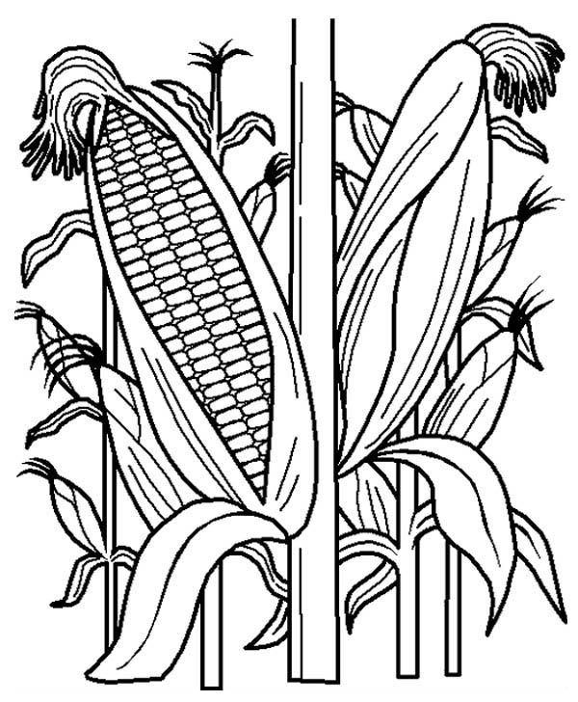

**3 The world is changing fast   
and warming year by year;   
a tipping point is close,  
the time to act is here.  
We’ll work and pray;  
as nature bleeds  
we’ll sow the seeds  
of hope today.**

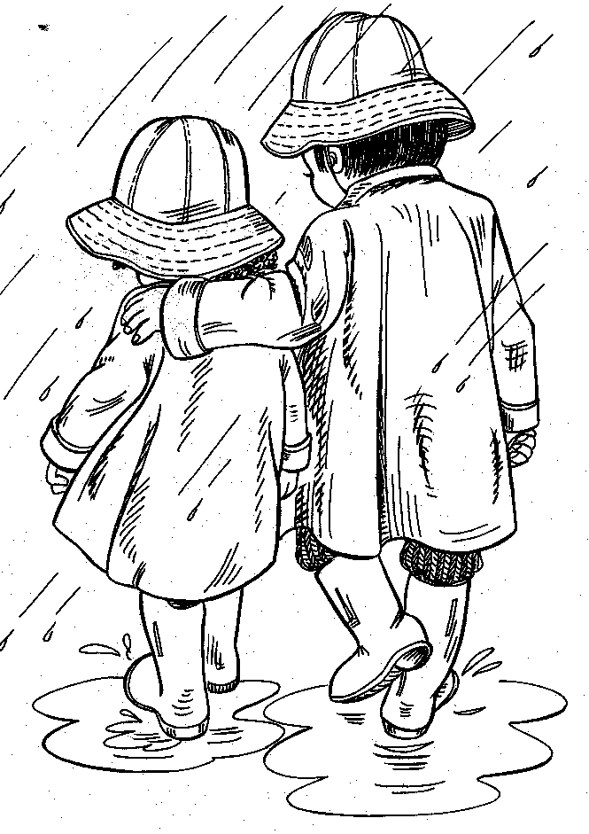

**4 Together we will walk                                    
the new way you reveal;  
our planet cries from wounds                     ‘   
that love alone can heal.  
Inspire us, Lord,  
to give and care,   
that all may share  
your earth restored.**

**Brian Davis © 2021 Jubilate Hymns**

**THE PEACE**

We are the family of God, created and called to live together in love and peace. May we know God’s presence among us, as we share his peace.

The peace of the Lord be always with you

**and also with you.**

**HYMN 546 ‘O Lord my God, when I in awesome wonder’**

**PREPARING THE TABLE**

With this bread that we bring

**we shall remember Jesus.**

With this wine that we bring

**we shall remember Jesus.**

Bread for his body, wine for his blood,

Gifts from God to his table we bring.

**We shall remember Jesus**

**EUCHARISTIC PRAYER**

The Lord is here

**His Spirit is with us**

Lift up your hearts

**We lift them to the Lord**

Let us give thanks to the Lord our God

**It is right to give thanks and praise**

Lord of all life,

you created the universe,

where all living things reflect your glory.

You give us this great and beautiful earth,

to discover and to cherish.

You give us the fish in the sea,

the birds of the air,

and every plant and tree;

the life that sleeps in the winter earth,

and awakens again in the spring.

You made us all, each wonderfully different,

to join with the angels and sing your praise:

**Holy, holy, holy Lord,**

**God of power and might,**

**heaven and earth are full of your glory.**

**Hosanna in the highest**.

We thank you, loving Father,

because, when we turned away,

you sent Jesus, your Son.

He gave his life for us on the cross and shows us the way to live. Send your Holy Spirit

that these gifts of bread and wine

may be for us Christ's body and his blood.

On the night before he died, when darkness had fallen,

Jesus took bread.

He gave thanks, broke it,

and shared it with his disciples, saying:

'This is my body, given for you. Do this to remember me.'

After they had eaten,

Jesus took the cup of wine, gave thanks,

and shared it with his disciples, saying:

'This is my blood, poured out for you and for many,

for the forgiveness of sins.'

So Father, with this bread and this cup

we celebrate his love, his death, his risen life.

As you feed us with these gifts, send your Holy Spirit,

and change us more and more to be like Jesus our Saviour.

Help us, Father, to love one another,

as we look forward to that day when suffering is ended,

and all creation is gathered in your loving arms.

And now with Michael, Paul and all your saints

we give you glory, through Jesus Christ,

in the strength of the Spirit, today and for ever. **Amen**

**THE LORD’S PRAYER**

Jesus taught us to call God our Father, so we have the courage to say

Our Father in heaven,  
hallowed be your name,  
your kingdom come,  
your will be done,  
on earth as in heaven.  
Give us today our daily bread.  
Forgive us our sins  
as we forgive those who sin against us.  
Lead us not into temptation  
but deliver us from evil.  
For the kingdom, the power,  
and the glory are yours  
now and for ever.  
Amen.

**THE BREAKING OF THE BREAD**

We break this bread to share in the body of Christ.

**Though we are many, we are all one body,**

**because we all share in one bread.**

**THE INVITATION TO COMMUNION**

Bread and wine –

the gifts of God for the people of God.

May we who share these gifts

be found in Christ

and Christ in us.

*We come forward for a blessing or to receive Holy Communion.*

*While Communion is being shared, you are invited to join in with* **HYMN 284 ‘For the fruits of all creation, thanks be to God’**

**THE PRAYER AFTER COMMUNION**

**Lord, we have broken your bread**

**and received your life.**

**By the power of your Spirit**

**keep us always in your love;**

**through Jesus Christ our Lord.**

**Amen.**

**FINAL HYMN** **484 ‘You shall go out with joy’**

**BEING BLESSED & SENT OUT**

The love of the Lord Jesus

draw you to himself,

the power of the Lord Jesus

strengthen you in his service,

the joy of the Lord Jesus fill your hearts;

and the blessing of God almighty,

the Father, the Son, and the Holy Spirit,

be among you and remain with you always.

**Amen.**

Go in peace to love and serve the Lord.

**In the name of Christ. Amen.**

***Please stay behind to enjoy refreshments and conversation,***

*and be aware of those who would still prefer to keep their distance.*

Common Worship: Services and Prayers for the Church of England, material from which is included in this service is copyright © The Archbishop’s Council 2000.

Eucharistic Prayer taken from the Church of England Environment Group Harvest Thanksgiving. Hymns & songs published under CCLI Licence No 218389