THE PARISH CHURCH OF
ST. MICHAEL
ALNWICK

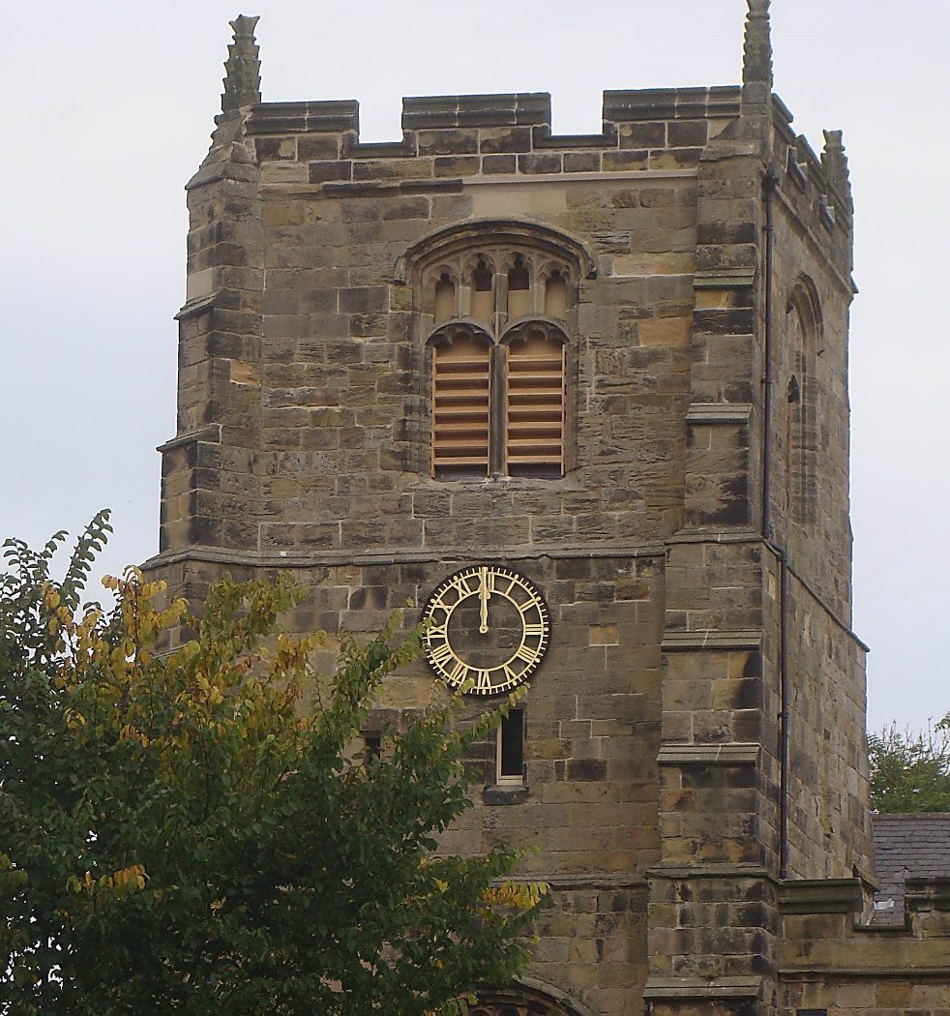

A SERVICE OF CELEBRATION ON THE COMPLETION OF THE TOWER PROJECT

Wednesday 29th September, 2021
7.00pm
with the Bishop of Berwick
WELCOME

Welcome to St. Michael’s, Alnwick on St. Michael’s Day as we gather in celebration and thanksgiving for the completion of our Tower Project and the dedication of our new ring of ten bells – and, of course, to hear them ring out across our town for the first time.

In August we were glad to have Mark, Bishop of Berwick with us to bless the newly-arrived bells and to catch sight of them before they were placed in the tower on the succeeding three days. Tonight we welcome Bishop Mark back to ‘finish the job’ as we celebrate the completion of the works, acknowledge with gratitude all who have helped to make this scheme possible and to dedicate the bells in the service of God and for the benefit of this town of Alnwick for many generations to come.

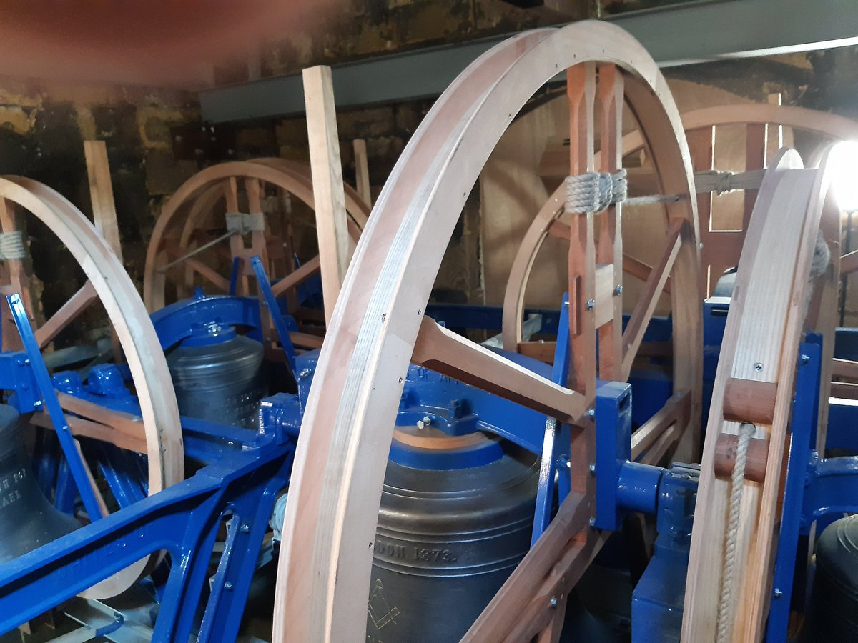

Although the government restrictions for Coronavirus have largely been lifted, we would ask, please, that whilst in church you continue to observe the usual conventions of hand sanitizing and the wearing of a face covering. Thank you.

WELCOME AND INTRODUCTION
Welcome in the name of Christ.
God’s grace, mercy and peace be with you
and also with you.

The Lord our God, the Almighty reigns.
Let us rejoice and shout for joy,
giving God the glory.

Glory to the Father and to the Son
and to the Holy Spirit;
as it was in the beginning is now
and shall be for ever. Amen.

HYMN
Ye holy angels bright,
who wait at God's right hand,
or through the realms of light
fly at your Lord’s command.
assist our song,
for else the theme
too high doth seem
for mortal tongue.

Ye blessèd souls at rest,
who ran this earthly race,
and now, from sin released,
behold the Saviour’s face,
his praises sound,
as in his sight
with sweet delight
ye do abound.

Ye saints, who toil below,
adore your heavenly King,
and onward as ye go
some joyful anthem sing;
take what he gives
and praise him still,
through good and ill,
who ever lives.

My soul, bear thou thy part,
triumph in God above,
and with a well-tuned heart
sing thou the songs of love;
let all thy days
till life shall end,
whate'er he send,
be filled with praise.

Richard Baxter (1615-1691)
and John Hampden Gurney (1802-1862)

OPENING PRAYERS

Everlasting God, you have ordained and constituted
the ministries of angels and mortals in a wonderful order:
grant that as your holy angels always serve you in heaven,
so, at your command,
they may help and defend us on earth;
through Jesus Christ your Son our Lord,
who is alive and reigns with you,
in the unity of the Holy Spirit,
one God, now and for ever.
Amen.

O Lord our God, we give you thanks for this day as we celebrate the completion of our Tower Project.
As you have given vision to your people and skill to craftsmen, so you inspire us to praise this day.
We thank you that our bells will enrich our worship. We thank you for all who will ring here, and grant that the message of the bells may lift the hearts of all who hear them, comfort the lonely and sorrowful, bring joy for new and married lives, strengthen the faithful and draw all people closer to you.
We make our prayer through Jesus Christ our Lord.
Amen.
FIRST READING
Genesis 28: 10-17

HYMN
Come, let us join our cheerful songs
with angels round the throne;
ten thousand thousand and are tongues,
but all their joys are one.

‘Worthy the Lamb that died.’ they cry,
‘to be exalted thus’;
‘Worthy the Lamb.’ our lips reply.
‘for he was slain for us.’

Jesus is worthy to receive
honour and power divine;
and blessings, more than we can give,
be, Lord, for ever thine.

Let all that dwell above the sky,
and air, and earth, and seas,
conspire to lift thy glories high,
and speak thine endless praise.

The whole creation joins in one
to bless the sacred name
of him that sits upon the throne,
and to adore the Lamb.

Isaac Watts (1674-1748)

SECOND READING
Revelation 5

SHORT ADDRESS

DEDICATION OF THE BELLS

One of the bell ropes is handed to the Bishop by Mr James Haseldine of Whites of Appleton, Bellhangers.
Bishop: Heavenly Father, pour your grace into the hearts of those who ring these bells, may they be mindful that they are rung to your honour and glory.
All: Amen.

The Bishop then hands the bell rope to the Vicar.

Bishop: Receive these bells into your charge. Take care that they are used in the service of God and his glory.

The Vicar hands the bell rope to Mr Jim Crowther who represents the Ringers.

Almighty and gracious God, today we dedicate our tower and its bells to your glory.
Let the times that these bells are rung be special; times as your people gather in your name for worship; for marriage; for mourning; for prayer.
Accept the ringing of these bells as one of the ways we sing your praises and give thanks to you.
Though they are not fire bells, may your Spirit use them to rekindle a fire in our hearts for you when we hear them ring.
Though they are not school bells, may we remember when we hear them that we always have more to learn at the feet of our teacher, Jesus Christ.
Though they are not alarm bells, may we remember when we hear them how vitally important our life with you is.
Let them truly be church bells, Lord, calling us out of the world to be be the Body of Christ and to have the mind of Christ.
Almighty God, you desire that your people worship you in the beauty of holiness. Let the beauty of these bells’ ringing remind us always of Christ.
Accept, Lord, these gifts of our hands and our hearts and give us your blessing now as we dedicate this tower and these bells to your service.
Amen.

Vicar: Bishop Mark, we ask you to dedicate to the glory of God the restored tower and the newly hung bells.

Bishop: Almighty God, we offer to you all the work that has been undertaken to restore this tower and prepare these bells for use. Bless, sanctify and hallow all that has been done in this tower.
Bless with your grace and skill all who will ring here, and grant that the message of the bells may lift the hearts of all who hear them, through Jesus Christ our Lord.
Amen.

HYMN
Ring out the bells, and let the people know
that God is worshiped by the church below:
to all around this truth the bells declare –
‘Your needs are lifted up to God in prayer!’

Ring out the bells, and let the people hear –
let hearts be open now, and faith draw near;
receive the grace that only God can give –
by word and symbol feed and grow and live.

Ring out the bells, and let the people sing
through changing seasons to our changeless King;
all perfect gifts are sent us from above –
respond with praises for such faithful love.

Ring out the bells until that glorious day
when death shall die and sin be done away:
then comes our God so everyone shall see –
let all the bells ring out in victory

Michael Perry (1942-1996)

THE GENERAL THANKSGIVING
Almighty God, Father of all mercies,
we your unworthy servants give you most humble and
hearty thanks
for all your goodness and loving kindness.
We bless you for our creation, preservation, and
all the blessings of this life;
but above all for your immeasurable love
in the redemption of the world by our Lord Jesus Christ,
for the means of grace, and for the hope of glory.
And give us, we pray, such a sense of all your mercies
that our hearts may be unfeignedly thankful,
and that we show forth your praise,
not only with our lips but in our lives,
by giving up ourselves to your service,
and by walking before you in holiness and
righteousness all our days;
through Jesus Christ our Lord,
to whom, with you and the Holy Spirit,
be all honour and glory,
for ever and ever.
Amen.

THE LORD’S PRAYER
As we look for the coming of your kingdom, Lord, we pray
Our Father, who art in heaven,
hallowed be thy name;
thy kingdom come;
thy will be done;
on earth as it is in heaven.
Give us this day our daily bread.
And forgive us our trespasses,
as we forgive those who trespass against us.
And lead us not into temptation;
but deliver us from evil.
For thine is the kingdom,
the power and the glory,
for ever and ever.
Amen.

HYMN
Now thank we all our God
with hearts and hands and voices,
who wondrous things hath done,
in whom his world rejoices;
who from our mother's arms
hath blessed us on our way
with countless gifts of love,
and still is ours to-day.

O may this bounteous God
through all our life be near us,
with ever joyful hearts
and blessed peace to cheer us;
and keep us in his grace,
and guide us when perplexed,
and free us from all ills
in this world and the next.

All praise and thanks to God
the Father now be given,
the Son, and him who reigns
with them in highest heaven,
the one eternal God,
whom earth and heaven adore;
for thus it was, is now,
and shall be evermore.

Martin Rinkart (1586-1649)
translated by Catherine Winkworth (1827-1878)

BLESSING
God keep you in the fellowship of Michael and all his saints.
Christ protect you by the ministry of the angels.
The Spirit make you holy in God’s service;
and the blessing of God almighty,
the Father, the Son, and the Holy Spirit,
be among you and remain with you always.
Amen.

Thank you for being with us for this special event this evening.
Please do take this order of service home with you
as a memento of the occasion.

As a hygiene precaution we have not passed a plate around for your offerings – but do still have major expenses to meet in completing the Tower Project. If you can, please place your offering on the plate as you leave church after the service.
Gift Aid envelopes are available.
Thank you.

Hymns are printed under CCLI Licence number 218389

