SAFEGUARDING CONTACTS

If you are concerned that a child or vulnerable adult has been harmed or is at risk of harm, do not hesitate to contact the Diocesan Safeguarding Adviser for advice and support.
Carol Butler: 07825 167 016 c.butler@newcastle.anglican.org
In the first instance the concern should be reported to the Parish Safeguarding Officer or Vicar. The Diocesan Safeguarding Advisor should then be contacted immediately.

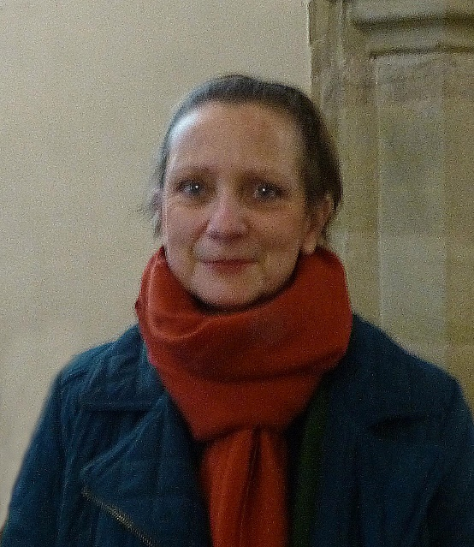  Patty Everitt  Parish Safeguarding Officer  07786 869 551  patty@patty-everitt.co.uk | 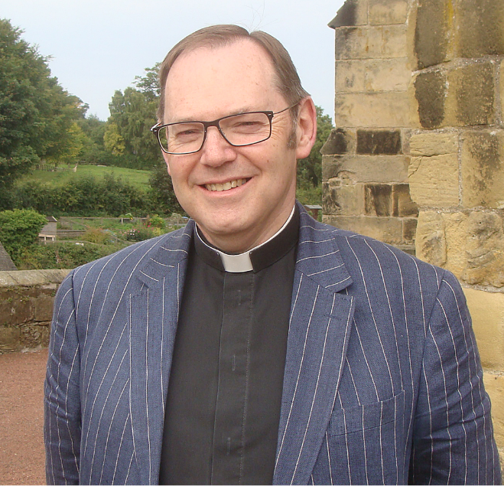  Rev’d Canon Paul Scott  Vicar  01665 603 078  paulscott1957@btinternet.com
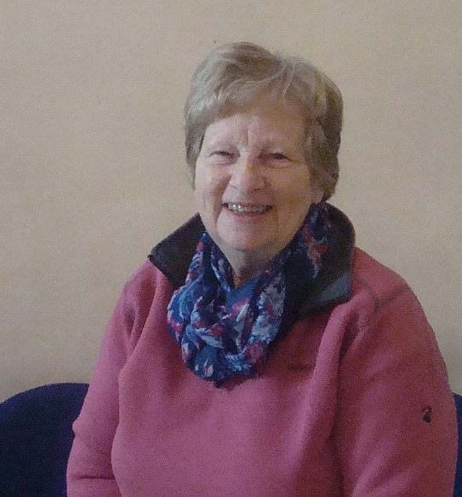  Anne Blades  Churchwarden  01665 602 020  d.blades2010@btinternet.com | 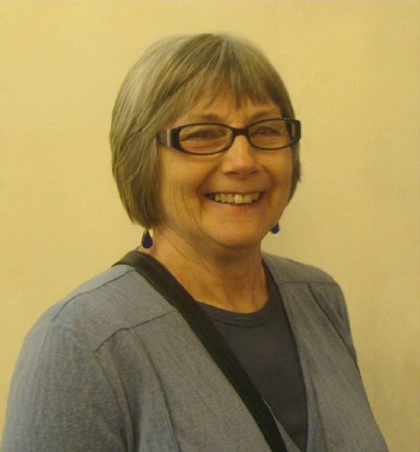  Pat Taylor  Churchwarden  01665 603 811  dickpat@btinternet.com

