**AN ACT OF WORSHIP FOR**

**GOOD FRIDAY**

*All sit or kneel in silence before the liturgy begins.*

The Collect for Good Friday.

Almighty Father,  
look with mercy on this your family  
for which our Lord Jesus Christ was content to be betrayed

and given up into the hands of sinners

and to suffer death upon the cross;  
who is alive and glorified with you and the Holy Spirit,  
one God, now and for ever. **Amen.**

**Hymn: My Song is Love Unknown**

My song is love unknown,  
my Saviour's love to me,  
love to the loveless shown,  
that they might lovely be.  
O who am I,  
that for my sake  
my Lord should take  
frail flesh, and die?  
  
He came from his blest throne,  
salvation to bestow;  
but men made strange, and none  
the longed-for Christ would know.  
But O, my Friend,  
my Friend indeed,  
who at my need  
his life did spend!

Sometimes they strew his way,  
and his sweet praises sing;  
resounding all the day  
hosannas to their King.  
Then 'Crucify!'  
is all their breath,  
and for his death  
they thirst and cry.  
  
They rise, and needs will have  
my dear Lord made away;  
a murderer they save,  
the Prince of Life they slay.  
Yet cheerful he  
to suffering goes,  
that he his foes  
from thence might free.  
  
Here might I stay and sing:  
no story so divine;  
never was love, dear King,  
never was grief like thine!  
This is my Friend,  
in whose sweet praise  
I all my days  
could gladly spend.

***The Liturgy of the Word***

The readings from the Old and New Testaments

*At the end*

This is the word of the Lord.

**Thanks be to God.**

**The Passion Gospel**

The Passion of our Lord Jesus Christ according to John.

*At the end*

This is the Passion of the Lord.

*No response is made and silence is kept.*

**The Sermon**

**Hymn: O Sacred Head Surrounded**

O sacred head, surrounded  
by crown of piercing thorn!  
O bleeding head, so wounded,  
so shamed and put to scorn!  
Death's pallid hue comes o'er thee,  
the glow of life decays;  
yet angel-hosts adore thee,  
and tremble as they gaze.  
  
Thy comeliness and vigour  
is withered up and gone,  
and in thy wasted figure  
I see death drawing on.  
O agony and dying!  
O love to sinners free!  
Jesu, all grace supplying,  
turn thou thy face on me.

In this thy bitter passion,  
good Shepherd, think of me  
with thy most sweet compassion,  
unworthy though I be:  
beneath thy cross abiding  
for ever would I rest,  
in thy dear love confiding,  
and with thy presence blest.

***The Proclamation of the Cross***

*A wooden cross is brought into the church and placed in the sight of the people.*

We adore you, O Christ, and we bless you,

**because by your holy cross you have redeemed the world.**

This is the wood of the cross, on which hung the Saviour of the world.

**Come, let us worship.**

O Saviour of the world,

who by your cross and precious blood have redeemed us,

**save us and help us, we humbly pray.**

*The people sit and silence is kept as we contemplate the mystery and meaning of the Cross.*

**The Reproaches:**

*My people, what have I done to you?  
What good have I not done for you?  
Listen to me.*

Is it nothing to you, all you who pass by?  
Look and see if there is any sorrow like my sorrow  
which was brought upon me,  
which the Lord inflicted on the day of his fierce anger.

Holy God,  
holy and strong,  
holy and immortal,  
have mercy upon us.

O my people, O my Church,  
what have I done to you,  
or in what have I offended you?  
Testify against me.  
I led you forth from the land of Egypt,  
and delivered you by the waters of baptism,  
but you have prepared a cross for your Saviour.

Holy God…  
  
I led you through the desert forty years,  
and fed you with manna.  
I brought you through tribulation and penitence,  
and gave you my body, the bread of heaven,  
but you prepared a cross for your Saviour.

Holy God…

*My people, what have I done to you?  
What good have I not done for you?  
Listen to me.*  
  
What more could I have done for you  
that I have not done?  
I planted you, my chosen and fairest vineyard,  
I made you the branches of my vine;  
but when I was thirsty, you gave me vinegar to drink,  
and pierced with a spear the side of your Saviour.

Holy God…

I gave you a royal sceptre,  
and bestowed the keys of the kingdom,  
but you have given me a crown of thorns.  
I raised you on high with great power,  
but you have hanged me on the cross.

Holy God…

*My people, what have I done to you?  
What good have I not done for you?  
Listen to me.*

My peace I gave, which the world cannot give,  
and washed your feet as a sign of my love,  
but you draw the sword to strike in my name,  
and seek high places in my kingdom.  
I offered you my body and blood,  
but you scatter and deny and abandon me.

Holy God…

I came to you as the least of your brothers and sisters;  
I was hungry and you gave me no food,  
I was thirsty and you gave me no drink,  
I was a stranger and you did not welcome me,  
naked and you did not clothe me,  
sick and in prison and you did not visit me.

Holy God,  
holy and strong,  
holy and immortal,  
have mercy upon us.

*Turn again my people, listen to me.*

Let your bearing to one another arise out of your life in Christ Jesus. He humbled himself and in obedience accepted the death of the cross. But I have bestowed on him the name that is above every name, that at the name of Jesus every knee should bow and every tongue confess that Jesus Christ is Lord.

**Father, hear our prayer and forgive us.**

**Unstop our ears,**

**that we may receive the gospel of the cross.**

**Lighten our eyes,**

**that we may see your glory in the face of your Son.**

**Penetrate our minds,**

**that your truth may make us whole.**

**Irradiate our hearts with your love,**

**that we may love one another for Christ’s sake.**

**Father, forgive us.**

**Hymn: There is a Green Hill Far Away**

There is a green hill far away,  
without a city wall,  
where the dear Lord was crucified,  
who died to save us all.

We may not know, we cannot tell,  
what pains he had to bear,  
but we believe it was for us  
he hung and suffered there.

He died that we might be forgiven,  
he died to make us good,  
that we might go at last to heaven,  
saved by his precious blood.

There was no other good enough  
to pay the price of sin;  
he only could unlock the gate  
of heaven, and let us in.

O dearly, dearly has he loved,  
and we must love him too,  
and trust in his redeeming blood,  
and try his works to do.

***The Intercession***

Lord, hear us.

**Lord, graciously hear us.**

***The Conclusion***

O Lord Jesus Christ,

Son of the living God,

set your passion, cross and death

between your judgement and our souls,

now and in the hour of our death.

Grant mercy and grace to the living,

rest to the departed,

to your Church peace and concord

and to us sinners forgiveness,

and everlasting life and glory;

for, with the Father and the Holy Spirit,

you are alive and reign,

God, now and for ever.

**Amen.**

*The ministers and people depart in silence.*

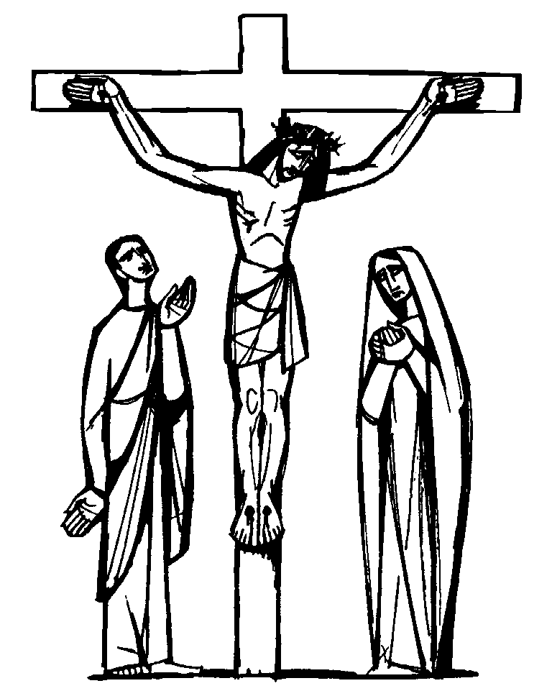

*Common Worship: Times and Seasons,* material from which is included in these services, is copyright ©The Archbishops’ Council 2006.

Hymns reproduced under CCLI Licence 218389