THE EUCHARIST ON EASTER DAY

***The Gathering***

*We turn to face the Easter Garden whilst it is blessed.*

The angel said to the women, ‘Do not be afraid; I know that you are looking for Jesus who was crucified. He is not here; for he has been raised, as he said.’

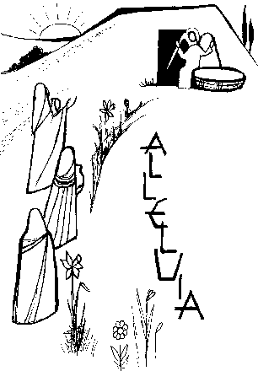Blessed are you, Lord God of all creation,  
the Father of our Lord Jesus Christ.  
To you be glory now and for ever.  
In your great mercy you have given us a new birth  
into a living hope  
through the resurrection of Jesus Christ from the dead.  
By your blessing, may we who have prepared this garden in celebration of his victory  
be strengthened in faith,  
know the power of his presence,  
and rejoice in the hope of eternal glory.  
Blessed be God, Father, Son, and Holy Spirit.

*All* **Blessed be God for ever.**

Risen Lord Jesus,  
as Mary Magdalene met you in the garden   
on the morning of your resurrection,  
so may we meet you today and every day:  
speak to us as you spoke to her;  
reveal yourself as the living Lord;  
renew our hope and kindle our joy;  
and send us to share the good news with others.

*All* **Amen.**

**Lighting the Easter Candle**

Christ yesterday and today,

**the beginning and the end,**

Alpha and Omega,

all time belongs to him,

and all ages;

**to him be glory and power,**

**through every age and for ever. Amen.**

This is the day when our Lord Jesus Christ passed from death to life. Throughout the world Christians celebrate the awesome power of God. As we hear his word and proclaim all that God has done, we can be confident that we will share his victory over death and live with him for ever.

*The Easter Candle is lit.*

May the light of Christ, rising in glory, banish all darkness from our hearts and minds.

The light of Christ.

**Thanks be to God** (Three times)

*The Easter Candle is placed in its stand*

**Alleluia. Christ is risen.**

**He is risen indeed. Alleluia!**

**HYMN**

**Prayers of Penitence** *(Which may be said at the Font)*

**Invitation to confession**

In baptism we died with Christ,  
so that as Christ was raised from the dead,  
we might walk in newness of life.   
Let us receive new life in him  
as we confess our sins in penitence and faith

*(Silence is kept)*

Lord Jesus, you raise us to new life.  
 Lord, have mercy.  
*All* Lord, have mercy.  
  
 Lord Jesus, you forgive us our sins.  
 Christ, have mercy.  
*All* Christ, have mercy.  
  
 Lord Jesus, you feed us with the living bread.  
 Lord, have mercy.  
*All* Lord, have mercy.

May the God of love and power  
forgive you and free you from your sins,  
heal and strengthen you by his Spirit,  
and raise you to new life in Christ our Lord.

All Amen.

*As the choir and altar party process to the Chancel we sing*

**Gloria in Excelsis**

All Glory to God in the highest,  
and peace to his people on earth.

Lord God, heavenly King,  
almighty God and Father,  
we worship you, we give you thanks,  
we praise you for your glory.

Lord Jesus Christ, only Son of the Father,  
Lord God, Lamb of God,  
you take away the sin of the world:  
have mercy on us;  
you are seated at the right hand of the Father:  
receive our prayer.

For you alone are the Holy One,  
you alone are the Lord,  
you alone are the Most High, Jesus Christ,  
with the Holy Spirit,  
in the glory of God the Father.  
Amen.

**The Collect**

The president introduces a period of silent prayer with the words ‘Let us pray’ or a more specific bidding.

The Collect is said.

All Amen.

***The Liturgy of the Word***

**Readings**

At the end the reader may say

This is the word of the Lord.

All Thanks be to God.

**Gospel Reading**

Alleluia, alleluia.  
I am the first and the last, says the Lord, and the living one;  
I was dead, and behold I am alive for evermore.

All Alleluia.

When the Gospel is announced the reader says

Hear the Gospel of our Lord Jesus Christ according to N.

All Glory to you, O Lord.

This is the Gospel of the Lord.

All Praise to you, O Christ.

**Sermon**

**The Creed**

Let us declare our faith  
in the resurrection of our Lord Jesus Christ.

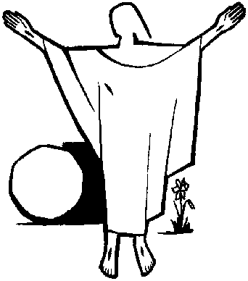All Christ died for our sins  
in accordance with the Scriptures;  
he was buried;  
he was raised to life on the third day  
in accordance with the Scriptures;  
afterwards he appeared to his followers,  
and to all the apostles:  
this we have received,  
and this we believe.  
Amen.

**Prayers of Intercession**

In joy and hope let us pray to the Father.

These responses may be used

Lord, in your mercy

All hear our prayer.

And at the end

Merciful Father,

All accept these prayers  
for the sake of your Son,  
our Saviour Jesus Christ.  
Amen.

***The Liturgy of the Sacrament***

**The Peace**

The risen Christ came and stood among his disciples  
and said ‘Peace be with you’.  
Then were they glad when they saw the Lord.

The peace of the Lord be always with you

All and also with you.

Let us offer one another a sign of peace.

All may exchange a sign of peace.

**Preparation of the Table**

**Taking of the Bread and Wine**

**Hymn**

The table is prepared and bread and wine are placed upon it.

The president takes the bread and wine.

Be present, be present,  
Lord Jesus Christ,  
our risen high priest;  
make yourself known in the breaking of bread.  
Amen.

**The Eucharistic Prayer**

The Lord be with you *(or)* The Lord is here.

All and also with you. *(or)* His Spirit is with us.

Lift up your hearts.

All We lift them to the Lord.

Let us give thanks to the Lord our God.

All It is right to give thanks and praise.

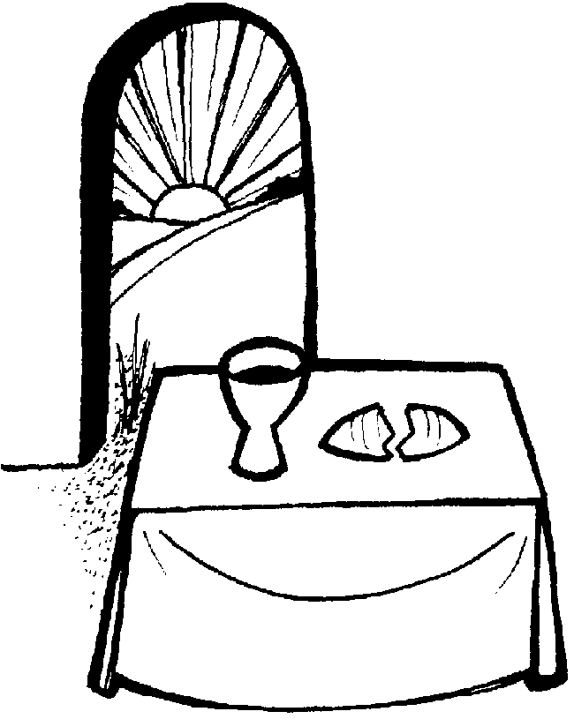

It is indeed right,   
it is our duty and our joy,   
at all times and in all places  
to give you thanks and praise,  
holy Father, heavenly King,  
almighty and eternal God,  
through Jesus Christ your Son our Lord.

And now we give you thanks  
because in his victory over the grave a new age has dawned,  
the long reign of sin is ended,  
a broken world is being renewed  
and humanity is once again made whole.

Therefore with angels and archangels,  
and with all the company of heaven,  
we proclaim your great and glorious name,  
for ever praising you and saying:

All Holy, holy, holy Lord,  
God of power and might,  
heaven and earth are full of your glory.  
Hosanna in the highest.  
Blessed is he who comes in the name of the Lord.  
Hosanna in the highest.

Accept our praises, heavenly Father,  
through your Son our Saviour Jesus Christ,  
and as we follow his example and obey his command,  
grant that by the power of your Holy Spirit  
these gifts of bread and wine  
may be to us his body and his blood;

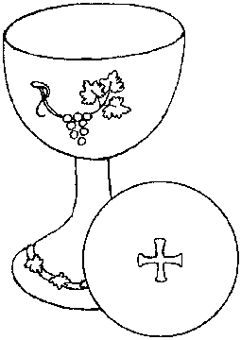who, in the same night that he was betrayed,  
took bread and gave you thanks;  
he broke it and gave it to his disciples, saying:  
Take, eat; this is my body which is given for you;  
do this in remembrance of me.

In the same way, after supper  
he took the cup and gave you thanks;  
he gave it to them, saying:  
Drink this, all of you;  
this is my blood of the new covenant,  
which is shed for you and for many for the forgiveness of sins.  
Do this, as often as you drink it,  
in remembrance of me.

Therefore, heavenly Father,  
we remember his offering of himself  
made once for all upon the cross;  
we proclaim his mighty resurrection and glorious ascension;  
we look for the coming of your kingdom,  
and with this bread and this cup  
we make the memorial of Christ your Son our Lord.

*Praise to you, Lord Jesus:*

All Dying you destroyed our death,  
rising you restored our life:  
Lord Jesus, come in glory.

Accept through him, our great high priest,  
this our sacrifice of thanks and praise,  
and as we eat and drink these holy gifts  
in the presence of your divine majesty,  
renew us by your Spirit,   
inspire us with your love  
and unite us in the body of your Son,  
Jesus Christ our Lord.

Through him, and with him, and in him,   
in the unity of the Holy Spirit,  
with all who stand before you in earth and heaven,  
we worship you, Father almighty,  
in songs of everlasting praise:

All Blessing and honour and glory and power  
be yours for ever and ever.  
Amen.

**The Lord’s Prayer**

Rejoicing in God’s new creation,

as our Saviour taught us, so we pray:

All Our Father in heaven,  
hallowed be your name,  
your kingdom come,  
your will be done,  
on earth as in heaven.  
Give us today our daily bread.  
Forgive us our sins  
as we forgive those who sin against us.  
Lead us not into temptation  
but deliver us from evil.  
For the kingdom, the power,  
and the glory are yours  
now and for ever.  
Amen.

**Breaking of the Bread**

The president breaks the consecrated bread.

We break this bread  
to share in the body of Christ.

All Though we are many, we are one body,  
because we all share in one bread.

**Agnus Dei**

All Lamb of God, you take away the sin of the world,  
have mercy on us.

Lamb of God, you take away the sin of the world,  
have mercy on us.

Lamb of God, you take away the sin of the world,  
grant us peace.

**Giving of Communion**

The president says the invitation to communion

Alleluia. Christ our passover is sacrificed for us.

All Therefore let us keep the feast. Alleluia.

The president and people receive communion.

Authorized words of distribution are used and the communicant replies

*Amen.*

During the distribution hymns and anthems may be sung.

**Prayer after Communion**

Silence is kept.

All Father of all,  
we give you thanks and praise,  
that when we were still far off  
you met us in your Son and brought us home.  
Dying and living, he declared your love,  
gave us grace, and opened the gate of glory.  
May we who share Christ’s body live his risen life;  
we who drink his cup bring life to others;  
we whom the Spirit lights give light to the world.  
Keep us firm in the hope you have set before us,  
so we and all your children shall be free,  
and the whole earth live to praise your name;  
through Christ our Lord.  
Amen.

***The Dismissal***

**Hymn**

**Acclamation**

Alleluia. Christ is risen.  
All He is risen indeed. Alleluia.  
 Praise the God and Father of our Lord Jesus Christ.  
All He has given us new life and hope.  
 He has raised Jesus from the dead.  
 God has claimed us as his own.  
All He has brought us out of darkness.  
 He has made us light to the world.  
 Alleluia. Christ is risen.  
All He is risen indeed. Alleluia.

**Blessing**

God the Father,  
by whose glory Christ was raised from the dead,  
strengthen you to walk with him in his risen life;  
and the blessing of God almighty,

the Father, the Son, and the Holy Spirit,

be among you and remain with you always.

**Amen.**

A minister says

Go in the peace of Christ. Alleluia, Alleluia.

All Thanks be to God. Alleluia, Alleluia.

The ministers and people depart.

**A prayer before leaving church**

**Help us to believe, Lord,**

**that ends are but beginnings**

**and that graves are but the doorway**

**to a new life.**

**For you are the Lord**

**of the living and the dead.**

**Amen.**

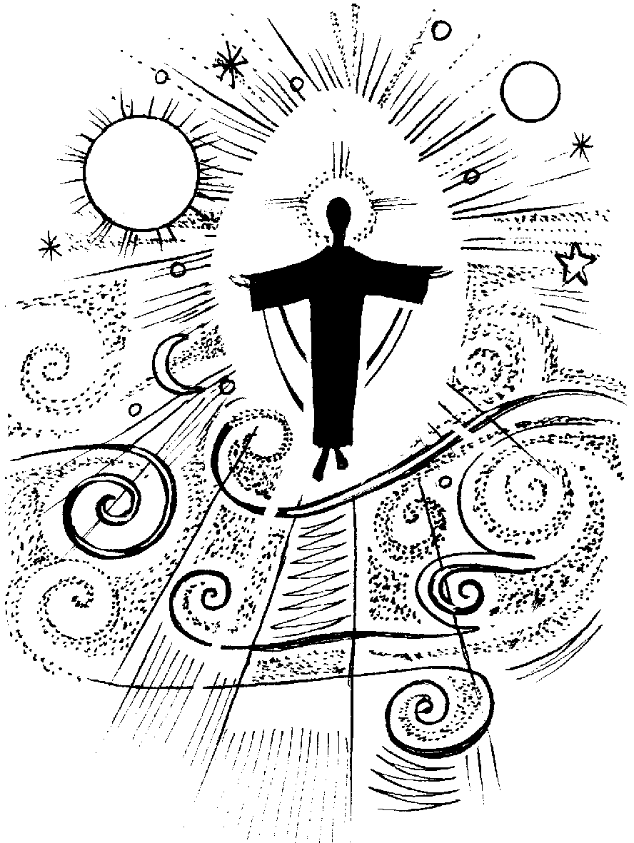





CCLI Licence No: 218389

Copyright acknowledgement

Some material included in this service is copyright: © The Archbishops' Council 2000