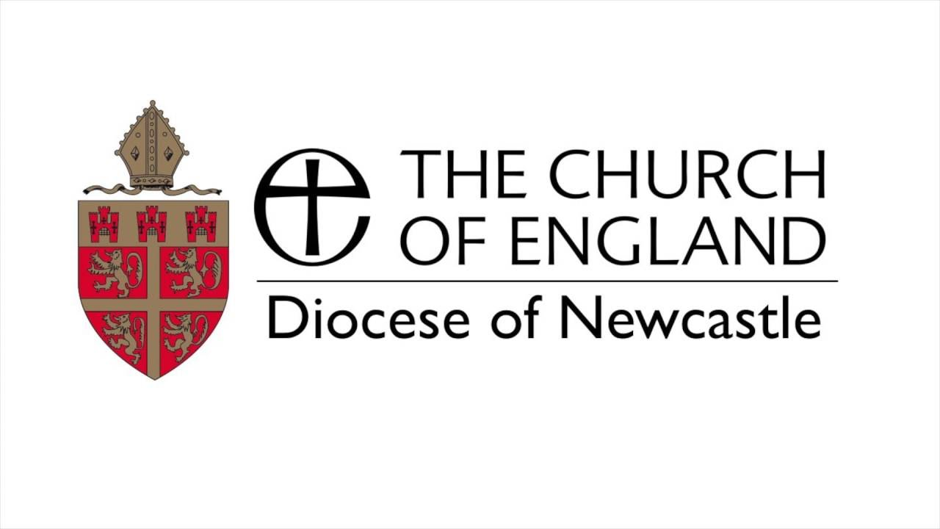
CORONAVIRUS

In line with instructions from the Archbishops of Canterbury & York we regret to inform you that all public worship must cease for the time being.

St. Michael’s will continue to be open each day for quiet prayer and reflection.

The Archbishops have written:

‘Being a part of the Church of England is going to look very different in the days ahead.
Our life is going to be less characterised by attendance at church
on Sunday, and more characterised by the prayer and service we offer each day. We may not be able to pray with people in the ways that we are used to, but we can certainly pray for people.
And we can certainly offer practical care and support.’

