CRAFT – TREASURE HUNT- PRAYER & MORE….

EASTER ALIVE!

9.30AM-11.30AM
18 APRIL - ST JAMES’ URC
(POTTERGATE, ALNWICK)
19 APRIL - ST PAUL’S RC CHURCH
(PERCY STREET, ALNWICK)

OPEN TO ALL IN SCHOOL YEARS 5-8

£1 SUBS PER SESSION
(INCLUDES REFRESHMENTS)

FOR MORE INFO: CLAIRE MEAD
YOUTH & SCHOOLS WORKER

07525 748728, contagious.alnwick@gmail.com
Facebook: @contagiousalnwick
www.contagiouscharity.webs.com
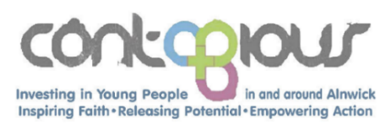

CRAFT – TREASURE HUNT- PRAYER & MORE….

EASTER ALIVE!

9.30AM-11.30AM
18 APRIL - ST JAMES’ URC
(POTTERGATE, ALNWICK)
19 APRIL - ST PAUL’S RC CHURCH
(PERCY STREET, ALNWICK)

OPEN TO ALL IN SCHOOL YEARS 5-8

£1 SUBS PER SESSION
(INCLUDES REFRESHMENTS)

FOR MORE INFO: CLAIRE MEAD
YOUTH & SCHOOLS WORKER

07525 748728, contagious.alnwick@gmail.com
Facebook: @contagiousalnwick
www.contagiouscharity.webs.com

