SAFEGUARDING NOTICE

If you are concerned that a child or vulnerable adult has been harmed or is at risk of harm, do not hesitate to contact the Diocesan Safeguarding Adviser for advice and support.
Ruth Rogan: 07825 167 016 r.rogan@newcastle.anglican.org
In the first instance the concern should be reported to the Vicar/Churchwarden. The Diocesan Safeguarding Advisor should then be contacted immediately.

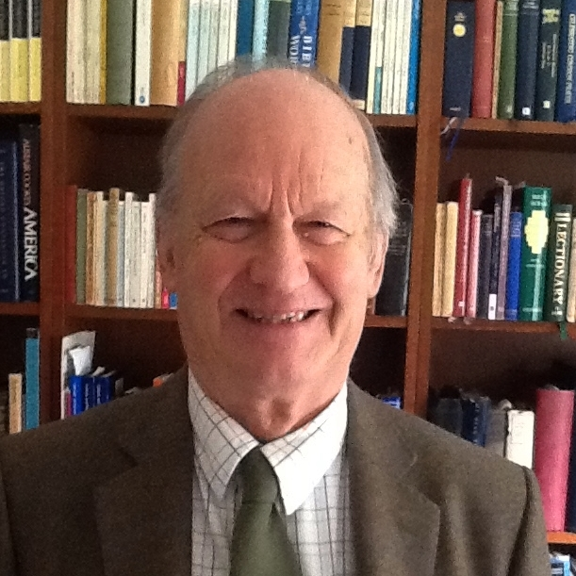  Rev’d Canon Alan Craig  Safeguarding Officer  01665 602 806  as.m.craig@talktalk.net | 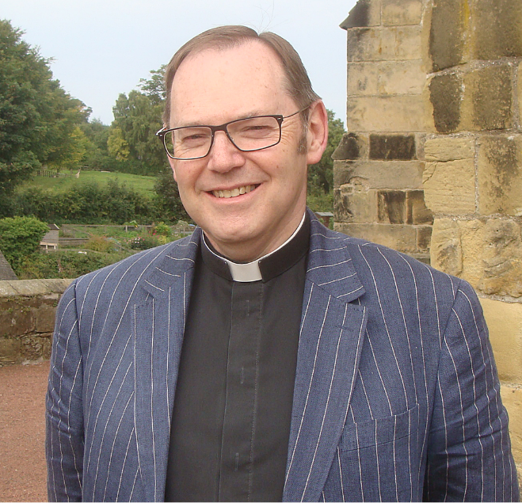  Rev’d Canon Paul Scott  Vicar  01665 603 078  paulscott1957@btinternet.com
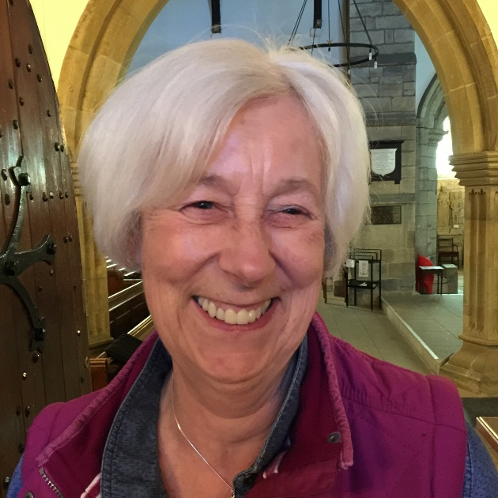  Jean Darby  Churchwarden  01665 603 850  jeandarby549@gmail.com | 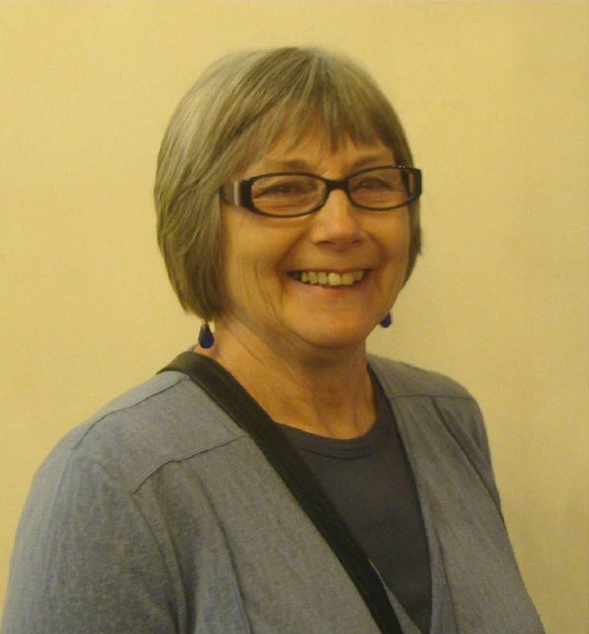  Pat Taylor  Churchwarden  01665 603 811  dickpat@btinternet.com

