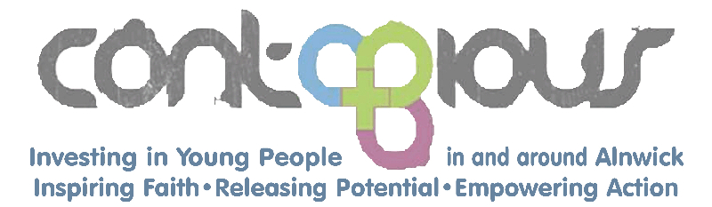
Charity Number: 1089954
WANTED – TREASURER
- Would you like to support Christian-based work among children and young people in the Alnwick area?
- Do you have experience with keeping accounts and managing finances?
- Are you comfortable and efficient at keeping financial records and using spreadsheets?
- Are you willing to give time to serving God and helping Contagious?
If the answer to these 4 questions is yes, then please read on!
Contagious is an ecumenical Christian charity seeking to serve the young people of Alnwick and the surrounding community by providing youth and schools work, Messy Church and the Mighty Oaks coffee van. As part of this, we are committed to following best practice in ensuring the safety of children and young people.
Financial administration plays a vital role in support of the work of Contagious.
We are looking for a volunteer Treasurer who can help us to manage the charity’s income and spending, keep proper accounts, review financial policies and make sure we have effective financial controls in place. This includes managing the pay and pension arrangements for our employed Youth and Schools Worker, dealing with invoices and payments, Gift Aid claims, and liaising with the charity’s independent financial examiner.
The main requirement for taking on this vital role is good financial administration skills and experience, and able to commit around 2 hours per week on average (but variable).
If you would like to more about what is involved please contact Andrew Duff, email duffandrew@btinternet.com or telephone 01665 605663 or email duffandrew@btinternet.com
Website: www.contagiouscharity.webs.com

