You are invited to…
A special Year 4 Rock Solid taster session

Thursday 30 June, 7-8pm
(Tuck shop: 8-8.15pm)
St James’ URC, Pottergate

make friends life skills fun games Christian values

For more info:
Claire Mead, Youth & Schools Worker
07525 748728, contagious.alnwick@gmail.com
www.contagiouscharity.webs.com
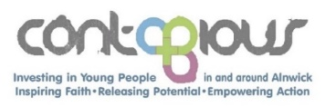

You are invited to…
A special Year 4 Rock Solid taster session

Thursday 30 June, 7-8pm
(Tuck shop: 8-8.15pm)
St James’ URC, Pottergate

make friends life skills fun games Christian values

For more info:
Claire Mead, Youth & Schools Worker
07525 748728, contagious.alnwick@gmail.com
www.contagiouscharity.webs.com

You are invited to…
A special Year 4 Rock Solid taster session

Thursday 30 June, 7-8pm
(Tuck shop: 8-8.15pm)
St James’ URC, Pottergate

make friends life skills fun games Christian values

For more info:
Claire Mead, Youth & Schools Worker
07525 748728, contagious.alnwick@gmail.com
www.contagiouscharity.webs.com

You are invited to…
A special Year 4 Rock Solid taster session

Thursday 30 June, 7-8pm
(Tuck shop: 8-8.15pm)
St James’ URC, Pottergate

make friends life skills fun games Christian values

For more info:
Claire Mead, Youth & Schools Worker
07525 748728, contagious.alnwick@gmail.com
www.contagiouscharity.webs.com

