SAVE THE DATE!

FUN EASTER ACTIVITIES FOR SCHOOL YEARS 5-8

Tue 11 & Wed 12 April
10am-12noon
Alnwick Methodist Church

cooking, craft & more!
£1 subs per young person a session
(includes a drink and a snack)

Charity No. 1089954

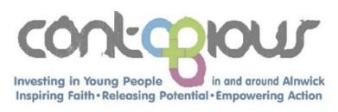

More info: Claire Mead, Youth & Schools Worker
07525 74828, contagious.alnwick@gmail.com
Consent forms available on our website:
www.contagiouscharity.webs.com
SAVE THE DATE!

FUN EASTER ACTIVITIES FOR SCHOOL YEARS 5-8

Tue 11 & Wed 12 April
10am-12noon
Alnwick Methodist Church

cooking, craft & more!
£1 subs per young person a session
(includes a drink and a snack)

Charity No. 1089954

More info: Claire Mead, Youth & Schools Worker
07525 74828, contagious.alnwick@gmail.com
Consent forms available on our website:
www.contagiouscharity.webs.com

