Coffee Morning for Angel Tree
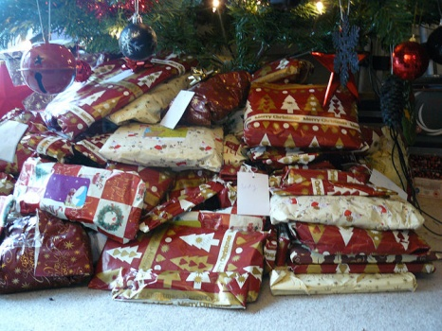
Saturday 21 November
10am-12 noon
St Michael’s Church
(Parish Room inside church)
Chat - cake stall – games - raffle
£1 entry per person
(includes hot drink & cake)
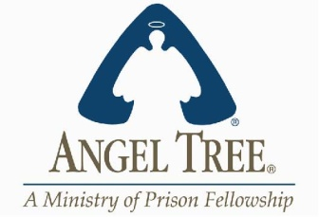

The Angel Tree project enables children of prisoners to receive Christmas presents from their absent parent.

