OPENING OF CHURCH INSTITUTE AT DENWICK
The Alnwick Guardian, Saturday, October 24th, 1908
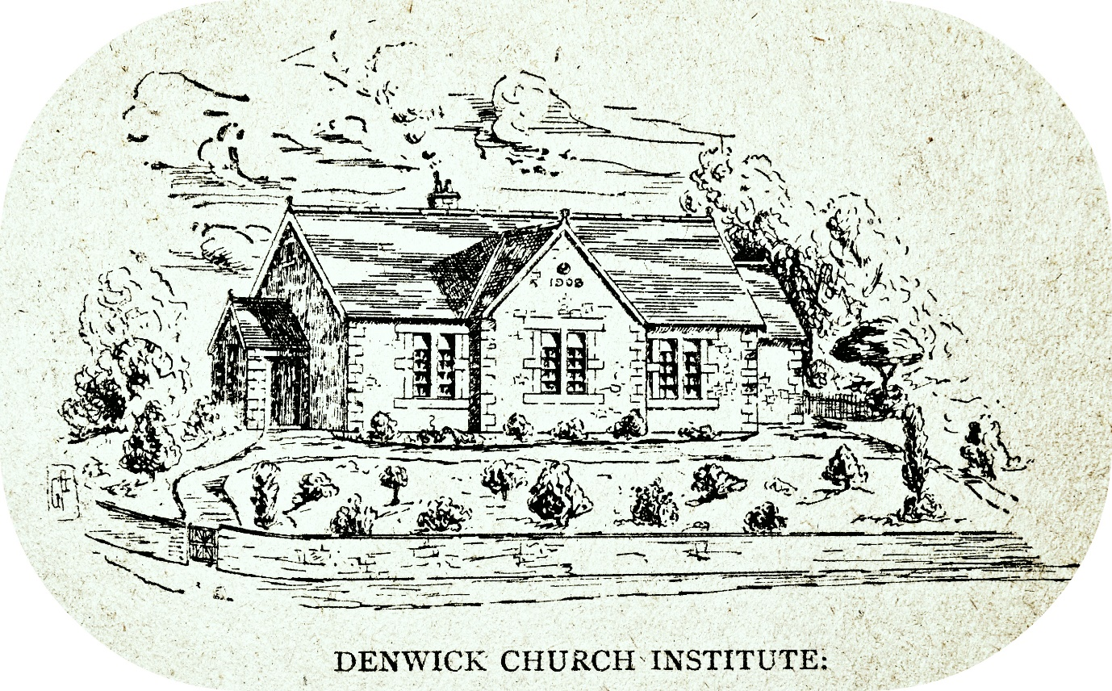

Her Grace the Duchess of Northumberland opened the new Church Institute at Denwick on Monday afternoon. The Institute has been built by His Grace for the benefit of the Church and of the people of the village in a very central part of the hamlet, and it is needless to say that the generosity of the Duke of Northumberland in bestowing such a gift upon the village is deserving of all praise and worthy the sincerest gratitude of the inhabitants. His Grace, in a matter of this kind, does nothing by halves, and not only is the hall a model of what a village hall should be, but it has been walled in and the ground surrounding it planted with shrubs. The entire outlay must have been very considerable, and judging from the solidarity and strength of the building, there is every likelihood of its being for many years a centre of village life, where lectures, concerts, and even dances may be held which will prove, what Sir Edward Grey has described a complete system of allotments might become “and antidote to the restlessness or depression which is so often characteristic of village life.” The plans for the hall were prepared at the Alnwick Castle Estates Offices, and the work has been carried out under the supervision of the Clerk of Works, Mr Temperley. The building is vested in the following trustees “for the use of the Church and the inhabitants of Denwick”:- The Vicar, the tenant of Denwick House, the two sidesmen for the time being, the curate working in Denwick district, and the Duke’s bailiff.
The opening ceremony took place at 4 p.m., by which hour the hall was crowded by villagers and others. Her Grace was accompanied to the platform by the Ladies Victoria and Muriel Percy, the Rev. R. R. Mangin, Vicar of Alnwick, and Mrs. Mangin, Colonel and Mrs. Kenyon-Slaney, Denwick House: Miss Grey, Bondgate Villa; and the Rev. Messrs. Mitchell and Ryan, curates. As the Duchess and party entered the hall, Messrs. Robinson and Taylor played “Chevy Chase.”
The Rev. Mr. Mangin, in some preliminary remarks, said it was generally recognised that two buildings were necessary in such a place, first a church and secondly a hall, in which people might meet for social intercourse and intellectual improvement, and these two buildings Denwick now possessed in a very excellent form. They had close by as beautiful a little church as one could find in the whole district, well attended, they were thankful to say, by the inhabitants of that place. And now to-day they had to congratulate them upon the further addition to their equipment in the shape of that beautiful hall, which would be used for different purposes. He did not know whether all of them were as susceptible as he was with regard to the nature of the room in which one had to meet one’s friends from time to time, but he thought some of them who were there would bear him out, that there were certain rooms, which would be nameless, not very far distant from that place, which could have nothing but the most depressing effect upon them, and seemed to call forth not only one’s lowest spirits, but one’s greatest irritation he would almost say. He thought it was an additional cause of congratulation to the people of Denwick that they had there such a bright and cheerful room in which surely there could be no ill-feeling ever evidenced, in which there could be nothing, he hoped, but harmony and good-will prevailing, because it was so cheerful and so pleasant in every possible way. He thought they all knew to whom the people of Denwick were indebted for this great privilege, the future enjoyment and use of that beautiful room. They were indebted, he need hardly remind them, to the generosity of one whose generosity never failed, even towards those who had but the slightest claim upon it. He referred, of course, to His Grace the Duke of Northumberland. (Applause.) They had put down upon their programme no formal vote of thanks to His Grace for his great generosity in building that room and placing it in the hands of trustees for the use of the Church and people in that village, and they did that because they felt that the whole nature of the gathering that day was to a great extent a vote of thanks to him. And the way in which they had received His Grace’s name was, he thought, a witness far more eloquent than any formal motion could possibly be of the deepest gratitude that was in their hearts to him who had added that gift to so many that he had given to them in that district. (Applause.) Now, there devolved upon him the pleasant task of asking the lady to declare the room open, who had come there, he had almost said, at risk to herself that afternoon, in circumstances as regarded the weather, in which they might have pardoned her if she had excused herself from the engagement on such a day as that. He referred, of course, to the Duchess of Northumberland. (Applause.) It seemed almost an impertinence for him to speak of introducing the Duchess to them at Denwick who were assembled there that day. They all knew her unfailing generosity and kindness towards all good work, they all were keenly aware of the quick sympathy which she ever extended to every case of necessity or need. But he thought, perhaps, ninety-nine out of every hundred, no, he would rather put it this way, because it seemed to express the extent of her sympathy more, that 999 out of 1,000 did not know the all-embracing nature of that kindness and sympathy, because it was always exhibited in such a kindly, unostentatious, and he would almost say in such a humble way. (Appl.)
He would not detain them with any further remarks but ask Her Grace the Duchess of Northumberland to kindly add to her kindness in coming there by declaring that gift of the Duke’s open. (Loud applause.)
Her Grace then said: - I have great pleasure in declaring this building open, with best wishes for its welfare. (Applause.)
Colonel Kenyon-Slaney said he thought they might congratulate themselves upon the success of their opening ceremony. The only thing they could not congratulate themselves upon was the weather, and it was beyond their province they could not command the weather. He had been asked by the Vicar to bring the ceremony to a very fitting and proper conclusion by proposing a vote of thanks. He could hardly express what an extremely pleasant duty it was, to propose on behalf of the whole of the inhabitants of Denwick, their very cordial and grateful thanks to Her Grace for her kindness in coming out to open that Church Institute. And in that vote of thanks he should like to include Lady Victoria and Lady Muriel Percy, who had so kindly accompanied her that afternoon. They owed that beautiful room to the kindness and liberality of the Duke of Northumberland, but at the same time they must not forget what they owed in this respect, and in many other respects, to Her Grace. They owed a very deep debt of gratitude to the Duchess for the interest and the sympathy that she had shown in that Church Institute of theirs ever since the idea was first started. She had received it, he knew, with the utmost favour, and as he said before, they owed her a debt of gratitude. (Applause.)
Living as they did almost in the shadow of Alnwick Castle, they knew quite well the sympathy and the kindness on all occasions of the Duke and Duchess to all who came in contact with them in any way whatever, and therefore he did not think he needed to expatiate on that any more, but before proposing the vote of thanks he should like to say one thing, that was that the best way in which they, inhabitants of Denwick, could show their appreciation of the kindness and liberality shown them was by making that Church Institute the very greatest success possible and redound to the satisfaction of the donors and to the credit of the inhabitants of that village. (Applause.)
Mr. Joseph Davison, Golden Moor, remarked that he had the greatest pleasure in seconding the vote of thanks to the Duchess and the Ladies Percy for coming there that day and opening that fine building which had been erected in the village. He hoped it might be everything that Col. Slaney had mentioned – a great benefit to the people of the district.
The vote was accorded with great heartiness.
Her Grace and the Ladies Percy remained for some time afterwards inspecting the building. It is lighted by petrol and in order to show them how brilliant and effective this light is, Mr. Wealleans lit one of the lamps suspended from the ceiling. Before finally leaving Her Grace had a short conversation with Miss Cunningham, the respected school-mistress of Denwick, in the course of which the Duchess made enquiries with regard to the number of children in attendance and their welfare generally.
Afterwards the large company present sat down to an excellent tea, at which the following ladies graciously presided at the tables: - Mesdames Wealleans, Robinson, Dixon, Cumming, and Misses Cunningham, Davison (Golden Moor), Towns, Fullarton, Rule, Dixon (Harlow Hill), and the ladies of the choir.
The day’s proceedings were wound up with a dance at which excellent music was supplied by Messrs. Robinson and Taylor.
Great credit is due Mr. James Wealleans, Denwick, for the assiduous manner in which he assisted in the carrying out of the arrangements connected with the opening.
In the evening a most enjoyable entertainment was given to a delighted audience by Mr. J. T. Willcox’s Scarleteers.

